Music database features

Html

The web page uses a wide range of html features to create a clear user interface resulting in a well structed site. The following html features were included throughout various aspects of the website.

- Tables

* Tables were used to show the contents of the data base in a clear and concise manner showing the artists, CD’s and tracks.
* Tables were used in the following sections
  + Display table , Album Table and Track Table

- Unordered lists

* An un ordered list was used to form the navigation bar for the website with each element in the list storing a link to the desired page.
* Unordered lists were used in the following sections
  + Front page , Nav bar main and nav bar

- Forms

* Forms were used to collect data from the user when editing, adding and searching relations.
* Forms were used in the following sections
  + Artist , search , Add form , Albums , Album search , Album form , Album form edit, Tracks , Track search , Track form and Track edit form .

- Heading tags

* Heading tags where used thoroughly throughout the site and were used to display a heading providing a brief of the current task or the part of the website the user is currently in.

- Title tags

* Title tags were used regularly in the system to make pages more easily identifiable allowing users to traverse the site with ease.

-Hyper links

* Hyperlinks where used throughout the site and served the functions of allowing users to access other pages.
* Examples include switching pages through the navigation bar and selecting to add, delete or edit a tuple, examples include the artist table

CSS

CSS was used to style key aspects of the web site to make certain sections easier to identify and use such as the navigation bar. The following css features were used to style the website and make it more presentable to users (all css features can be seen with the style sheet show in appendix 1.1) :

-Background Colour

* This feature enable me to set the background colour of certain sections of code to make the information easier to read and identify.

-text formatting

* This feature encompassed multiple smaller features allowing me to select the padding, size, colour, decoration, margin and display type for some selected text either within a class or another or more general html element.

- List formatting

This feature allowed me to select the text format, colour alignment size, any decoration of text within the list and back ground colour.

Classes

* Classes where used to make sections of code uniquely identifiable such as the navigation bar. This allowed for unique styles to be added to individual sections of the web site .

Java script

- Form validation

* This checks that the input to each field within a form meets the expected requirements / format. The input is taken and compared to multiple conditions. If any of the conditions are failed an appropriate error message is displayed.
* Form validation was used in the following sections.
  + Validation (appendix 1.,) search , Add form , Album search , Album form , Album form edit, , Track search , Track form and Track edit form .

- Live search (AJAX)

* The live search displayed a selected row from the current table based on the name/ search criteria entered by the user. The live search allows the user to enter data e.g. the name of an artist and displays a drop-down list of suggestions of similar tuples in the table.
* This feature can be seen in search , Album search , album form , Track search , track form

PHP

-Form validation

* This feature functions in a similar way to java script validation however this time the validation is performed on the server end. This provides as a backup form of validation in the even that java script validation in disabled.
  + This feature can be seen in server validation

- Linking different pages (include)

* This feature allows various php documents to be present within the same page for example the nav bar can be displayed on any page within the web site through the use of the include feature.
* This feature can be seen throughout the web site.

- Data sanitisation

* This feature convert any input into a text/string format to prevent any html, php or sql commands being executed from a user input. This functions as a security measure to prevent malicious activity.
* This feature can be seen in the following sections.
  + Server validation

SQL

-INSERT

* This feature inserts new tuples into the database.
* This feature can be seen in the following sections of the web site.
  + Add artist , add album , add track

-UPDATE

* This was used to change and amend values within the data base.
* This feature was used in the following sections.
  + Edit artist , edit album , edit track

-DELETE

* This feature was used to remove tuples from the database.
* This feature was used in the following sections
  + Artist data , Album data and Track data

-SELECT

* This feature was used in displaying the selected tuple(s) in the data base whether this was when displaying an entire table or returning a search result
* This feature was used in the following sections
  + Front page (1.0), Artist table , find ,Album table , find album , find track and track table

-COUNT

* This feature was used to determine the number of tuples for each relation in the data base
* This feature was used in front page (appendix 1.0)

Functionality

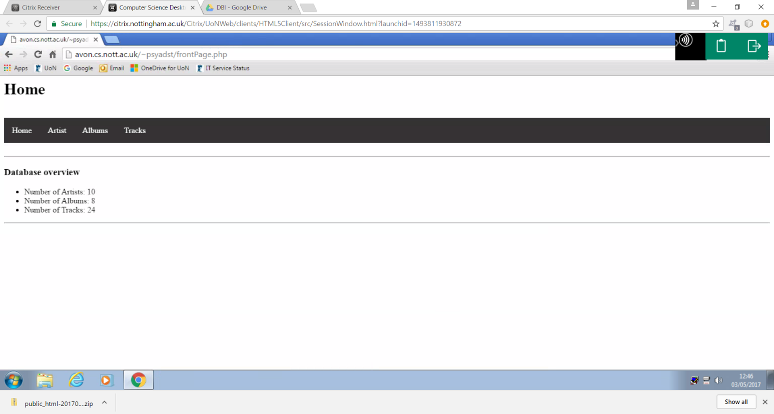

This figure shows the home page of the website with the number of artist, albums and tracks currently being stored within the database. The homepage also offers a navigation bar that allows the user to select which part of the website they wish to go to as illustrated throughout the report.

Artists

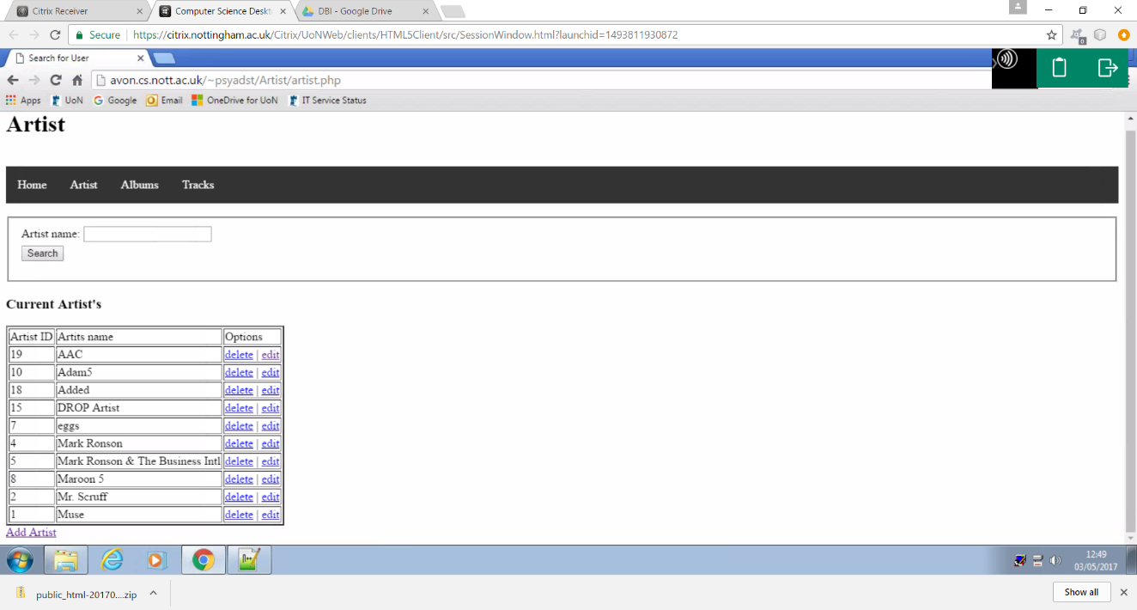The navigation bar successfully allowed the user to access the artist section of the web site when selected. This section allows users to view, search, edit, delete and add data within the artist table of the database.

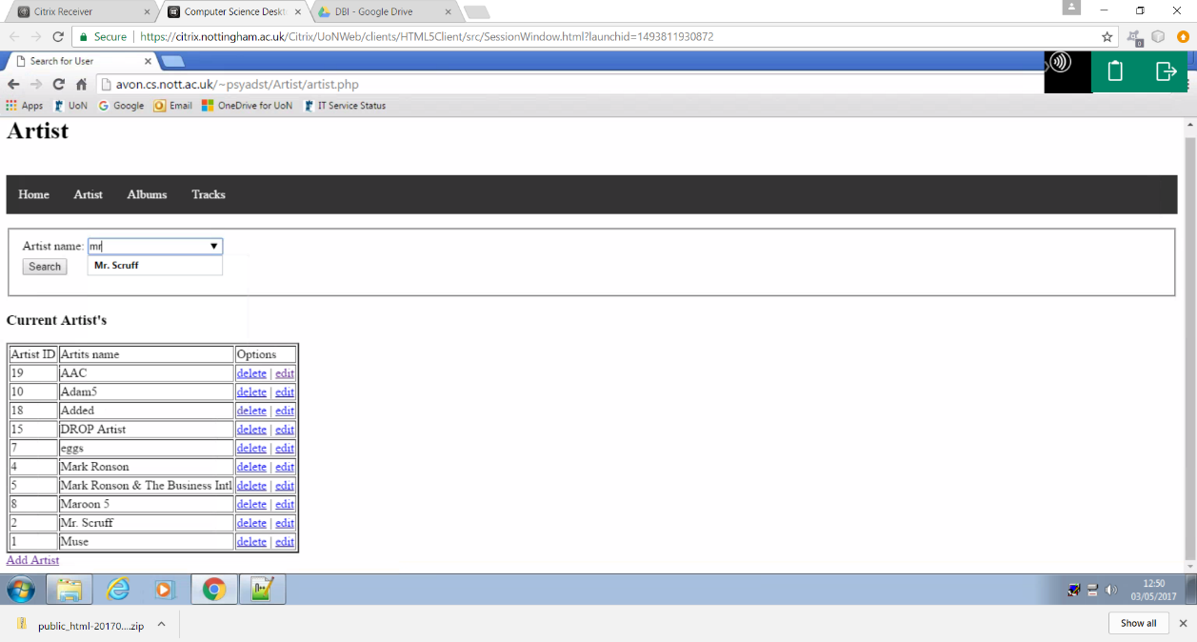Live search

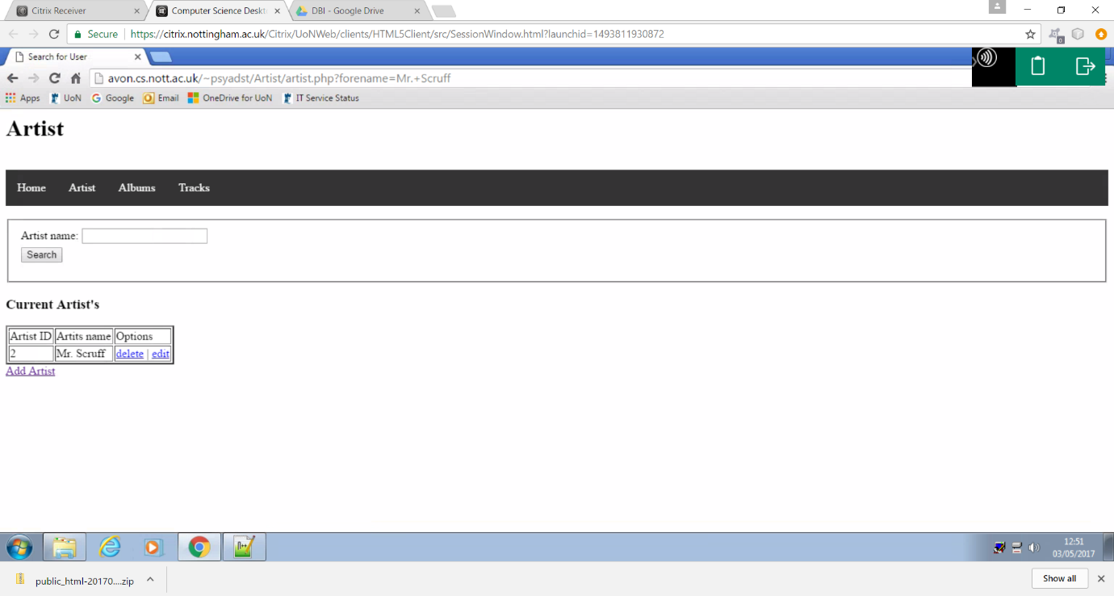

The images above demonstrated the websites live search functionality, where the user can enter a given search criteria and the web site will offer a list of suggestions that match the users input.

Delete

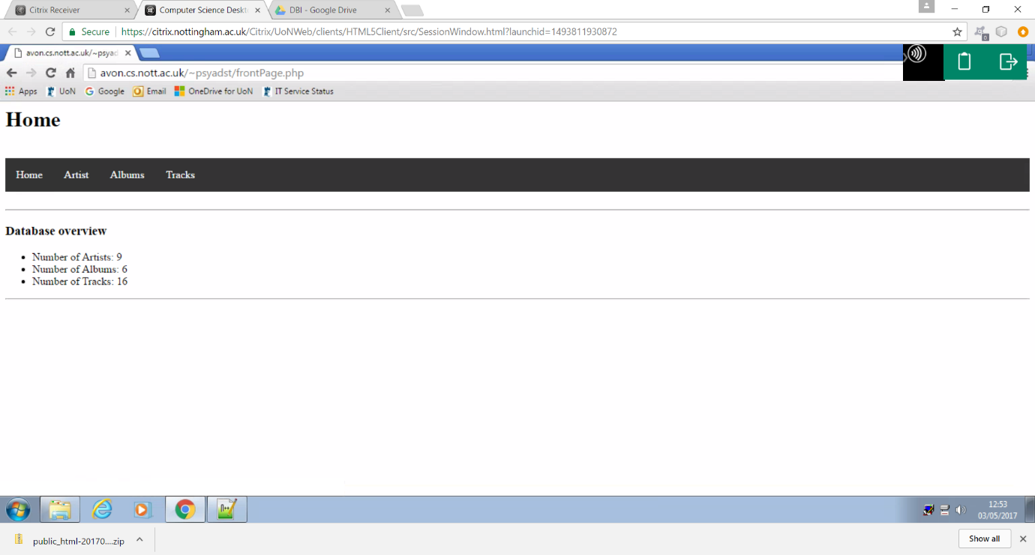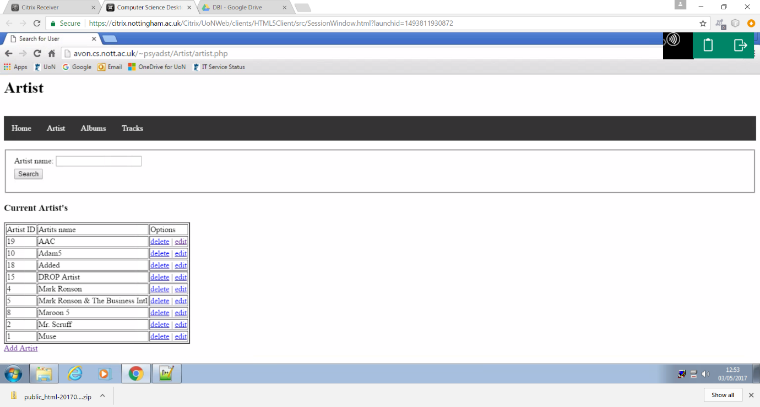

These figures shows the websites delete function, where as expected the artist “eggs” was successfully removed from the database. This is further demonstrated by the information displayed on the home page were it is shown that an artist has successfully been remove, and the total number of artists has been reduced by 1.

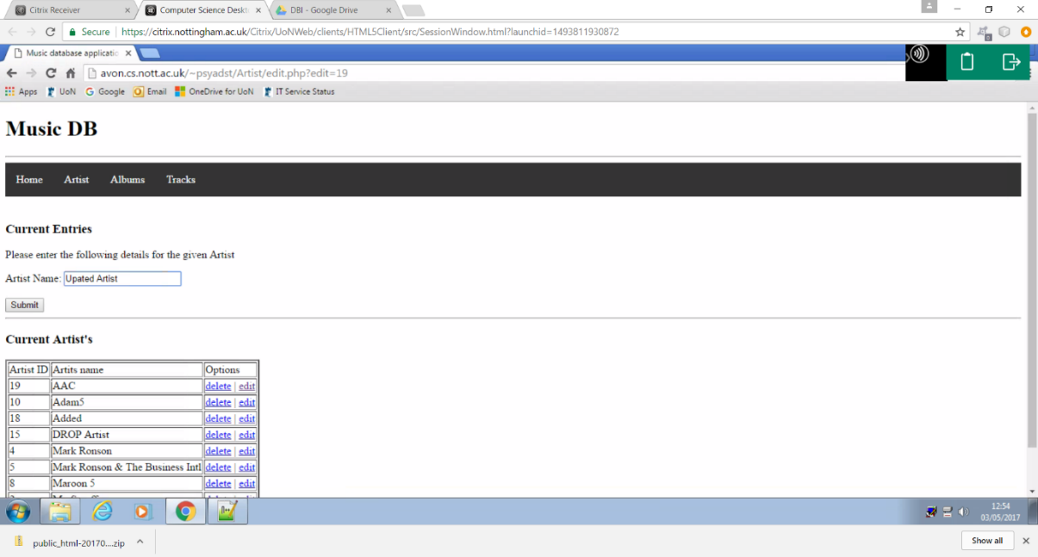Edit

In this example I am editing the artist name of the artist “AAC” in order to show the update functionality of the website.

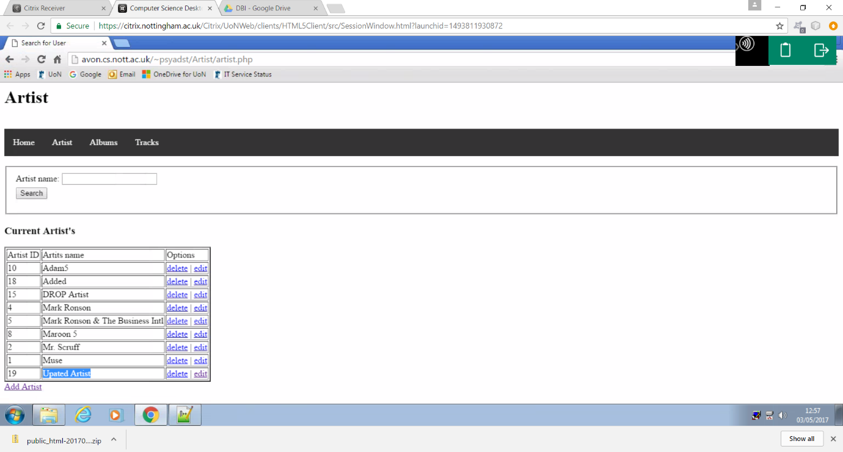

As seen in this screenshot the Artist name of “AAC” has been successfully updated to the value “updated artist” as expected.

Adding an artist

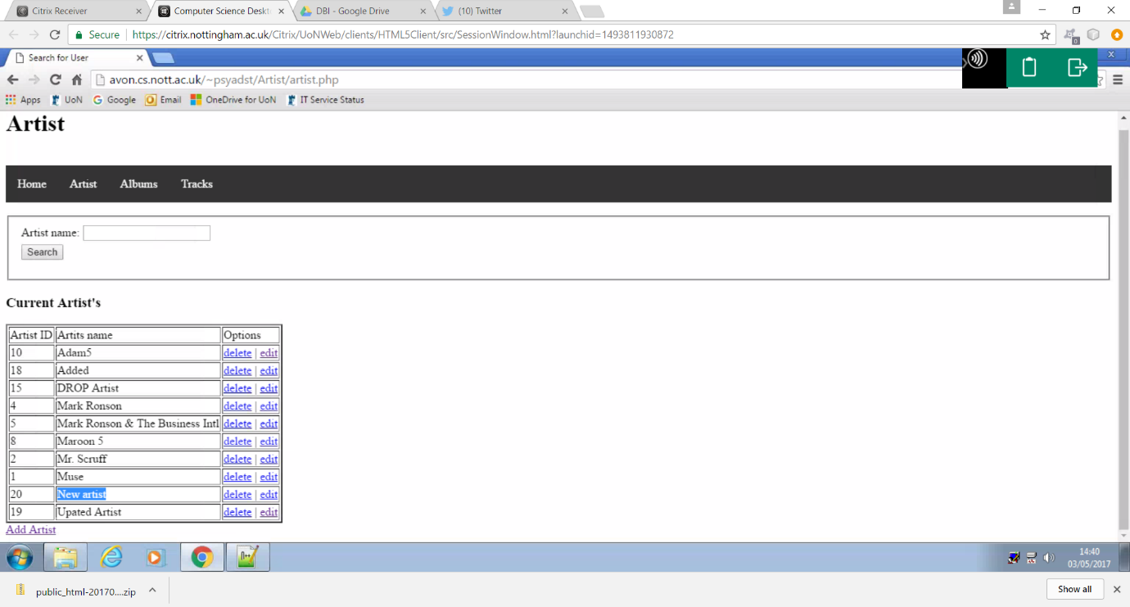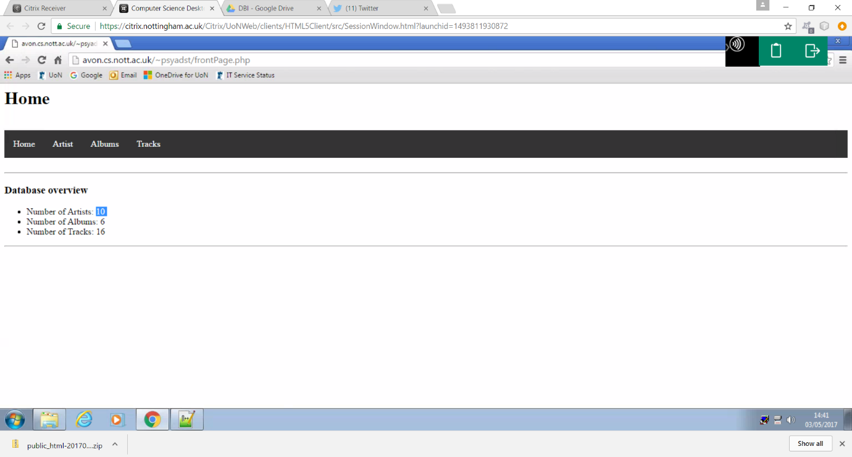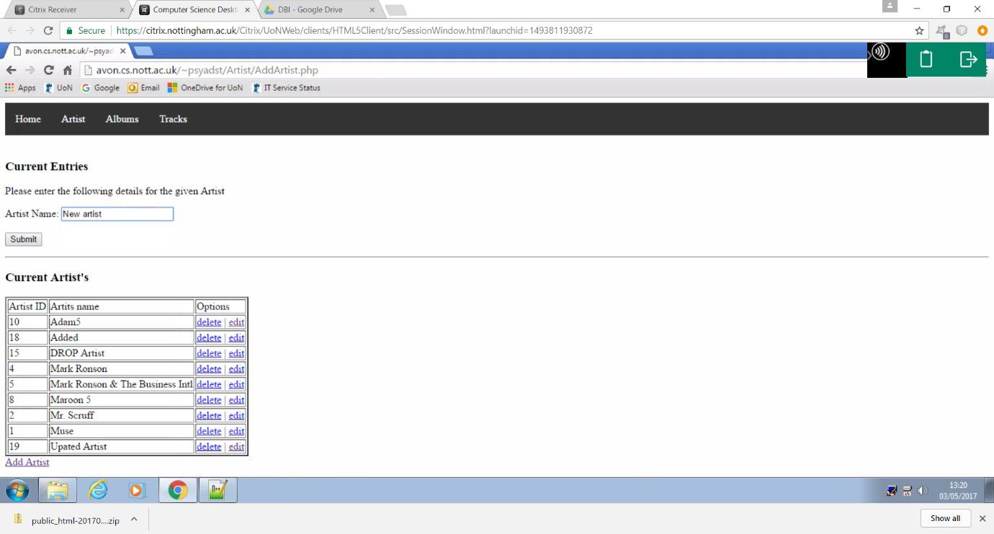

The next piece of functionality added was inserting an artist to the data base. As seen above the user can enter the name of the desired artist and the web site successfully stored the data within the artist table. This is further demonstrated by the information in the home page now once again showing that there are 10 artists in the data base.

Form validation

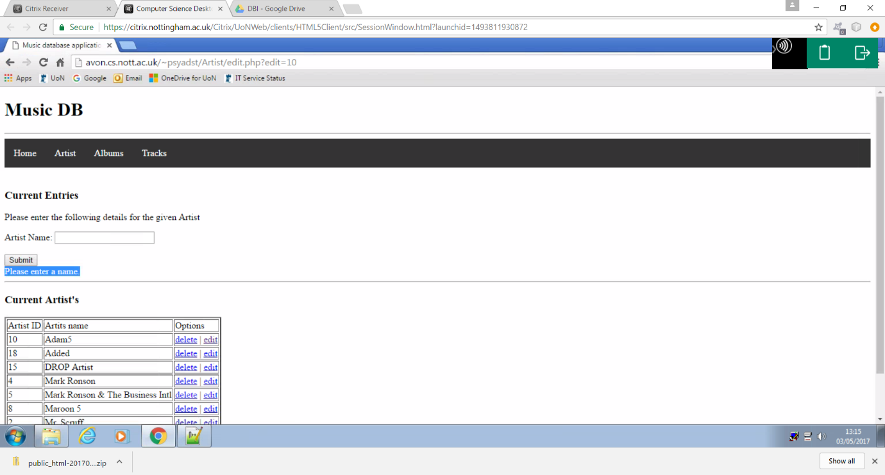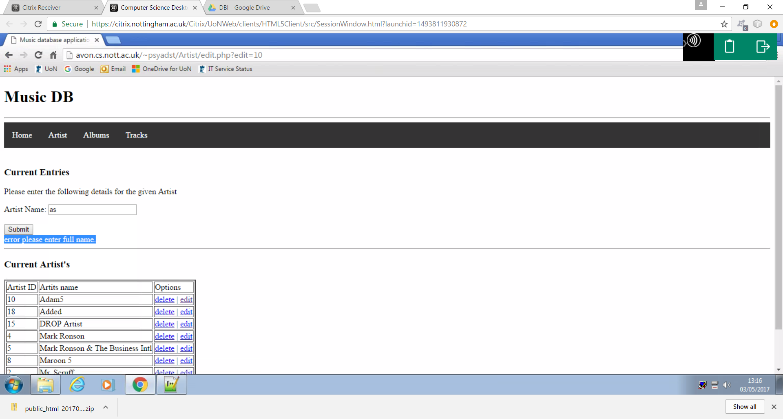

The figures above show that the required form validation has been performed successfully, preventing the user form entering any data that does not match the valid format.

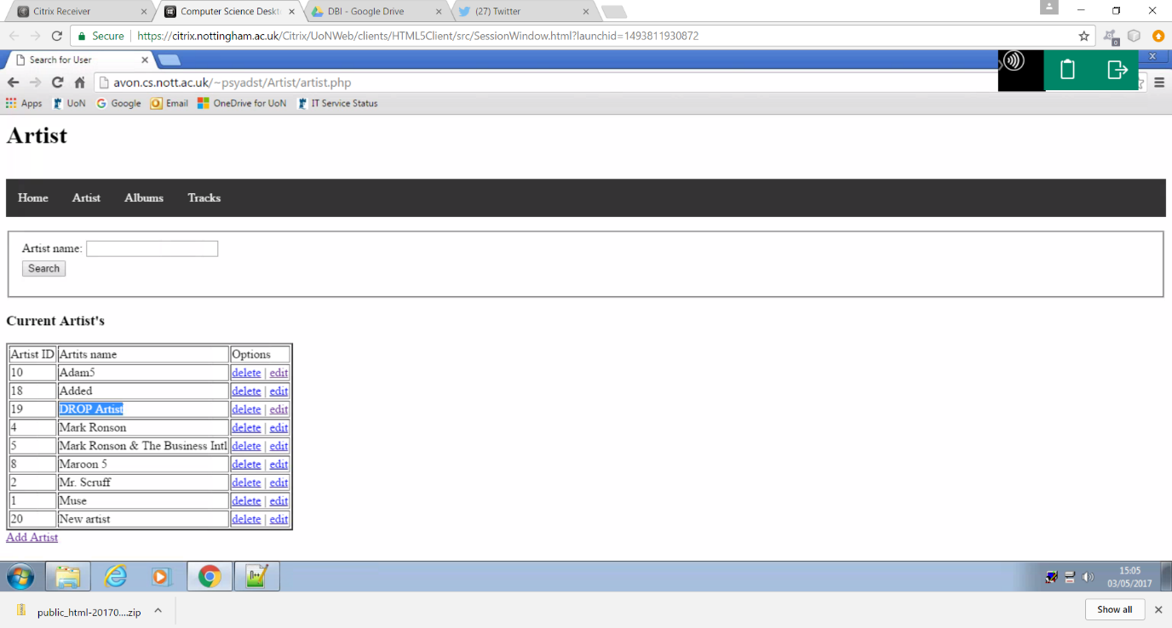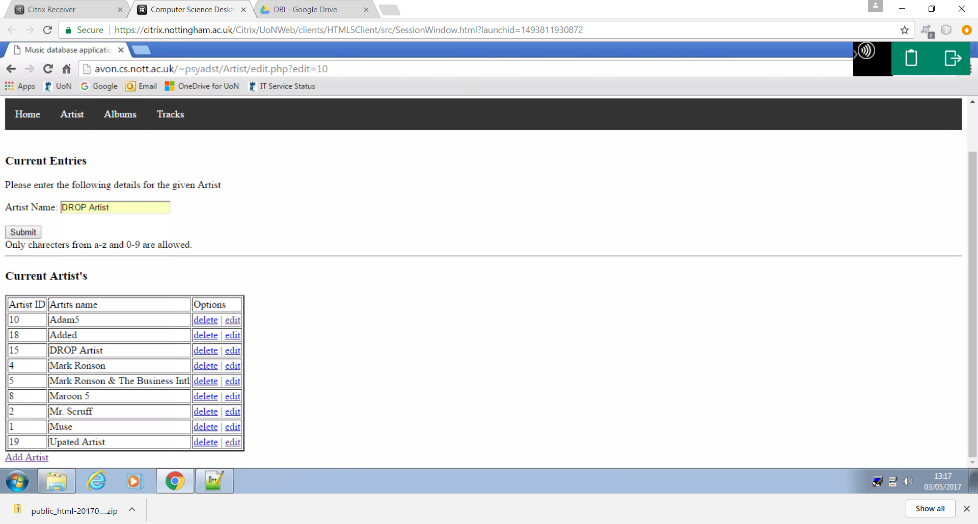

This example demonstrates data sanitation., where instead of executing the sql command the web site accepted the input as a string and updates the artist name as expected.

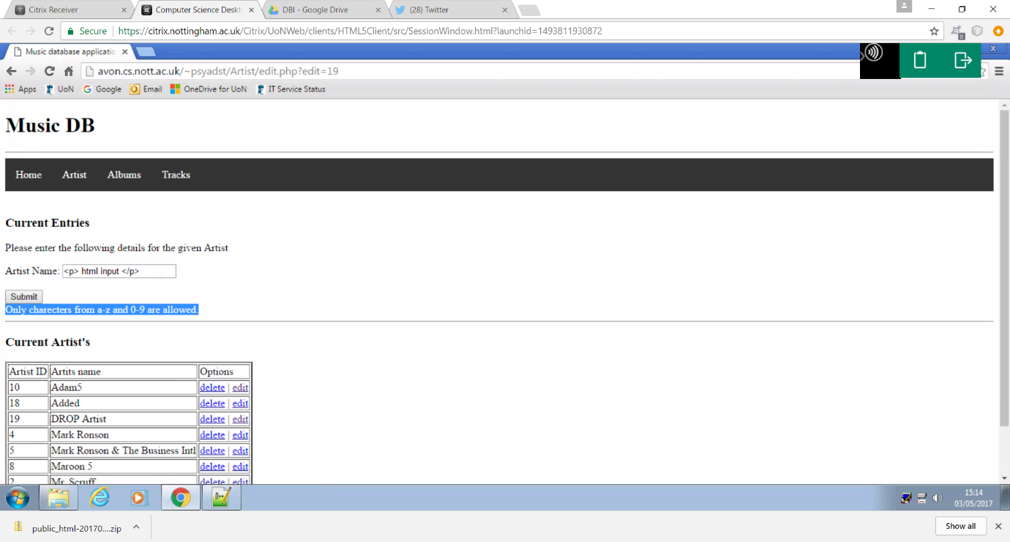

The final validation check performed is a format check where the web site ensures that the users input matches a specific set of “valid” characters

Albums

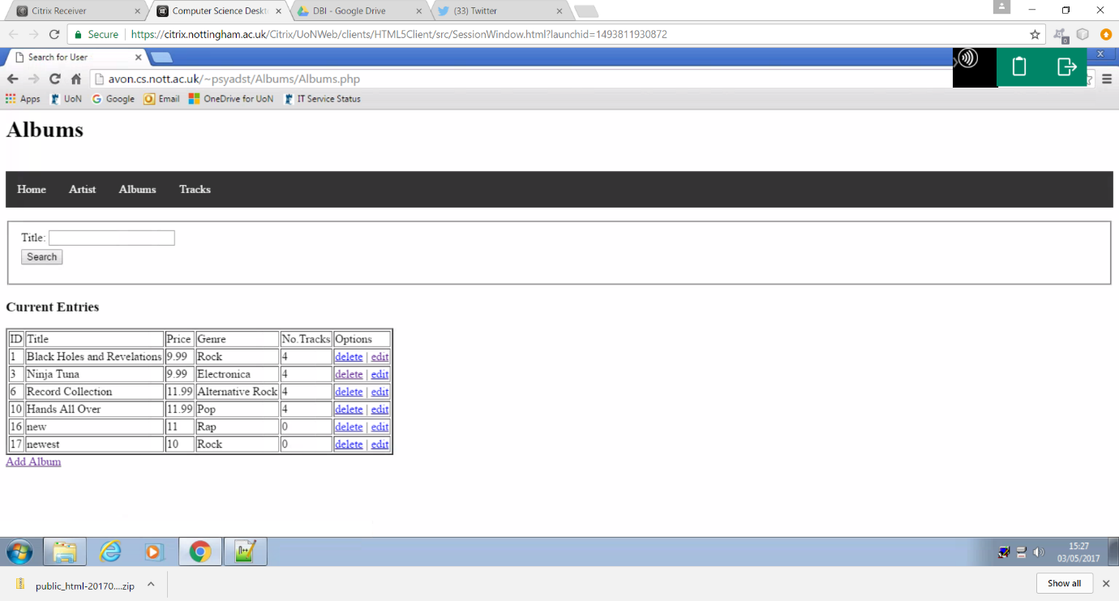

The navigation bar successfully allowed the user to access the albums section of the web site when selected. This section allows users to view, search, edit, delete and add data within the album table of the database.

Live search

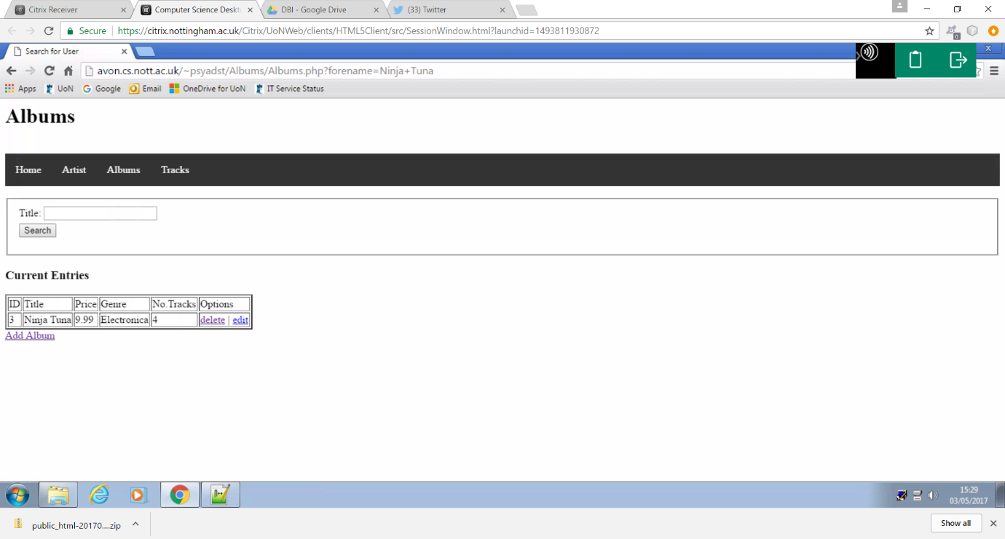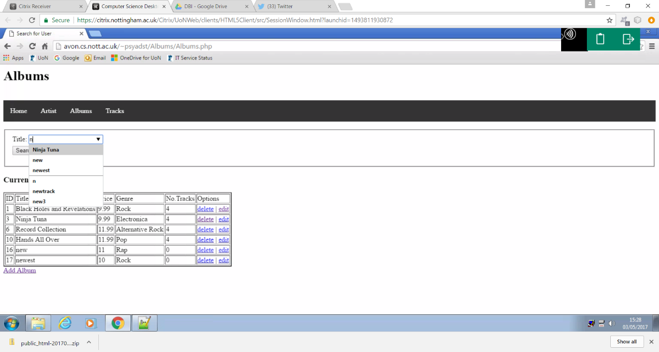

This example demonstrates the live search functionality where the user can enter a given search criteria and the web site will offer a list of suggestions that are most like the users input.

Edit

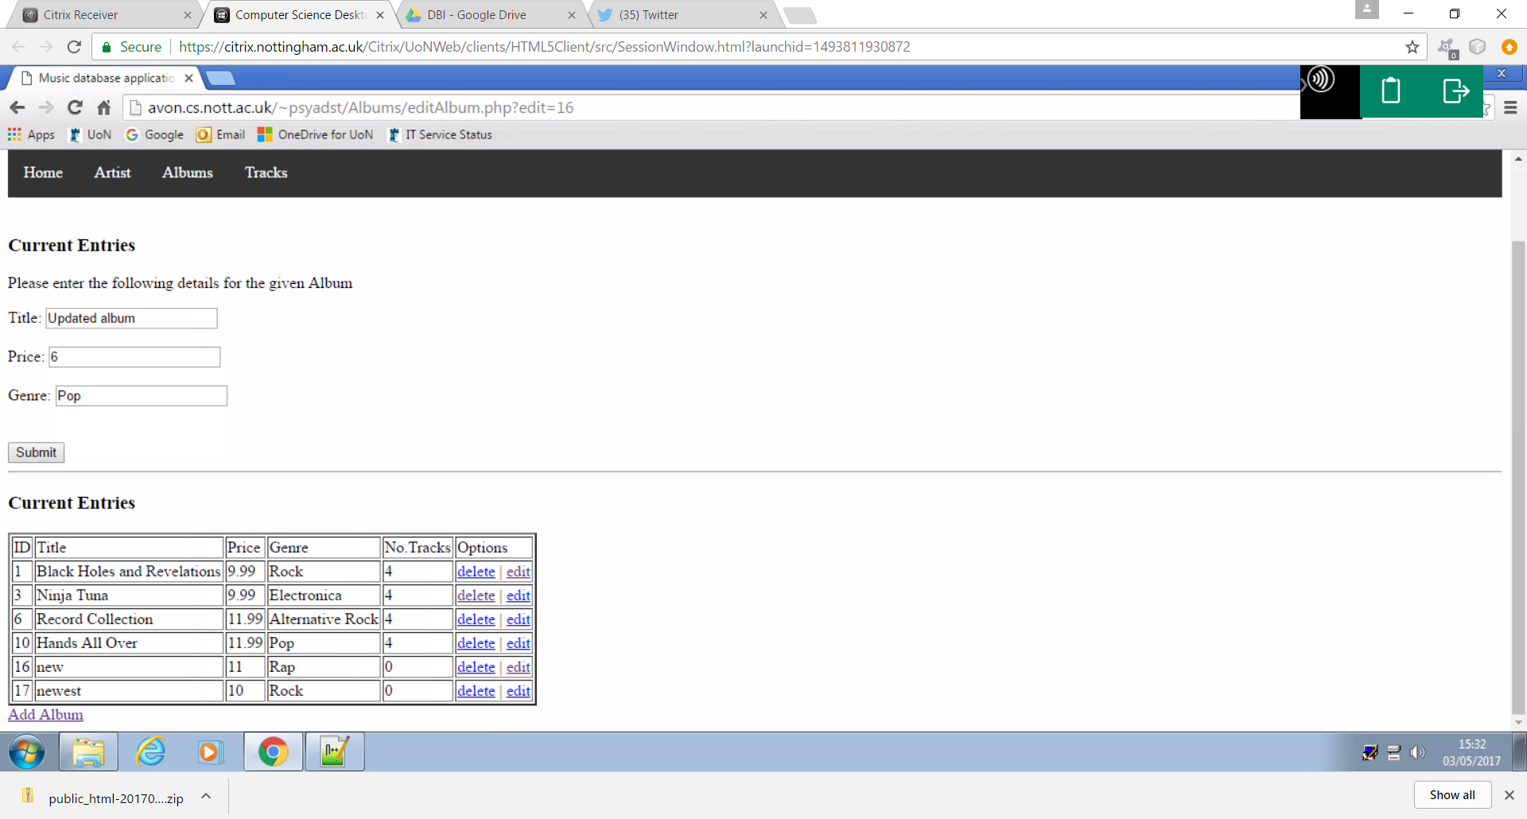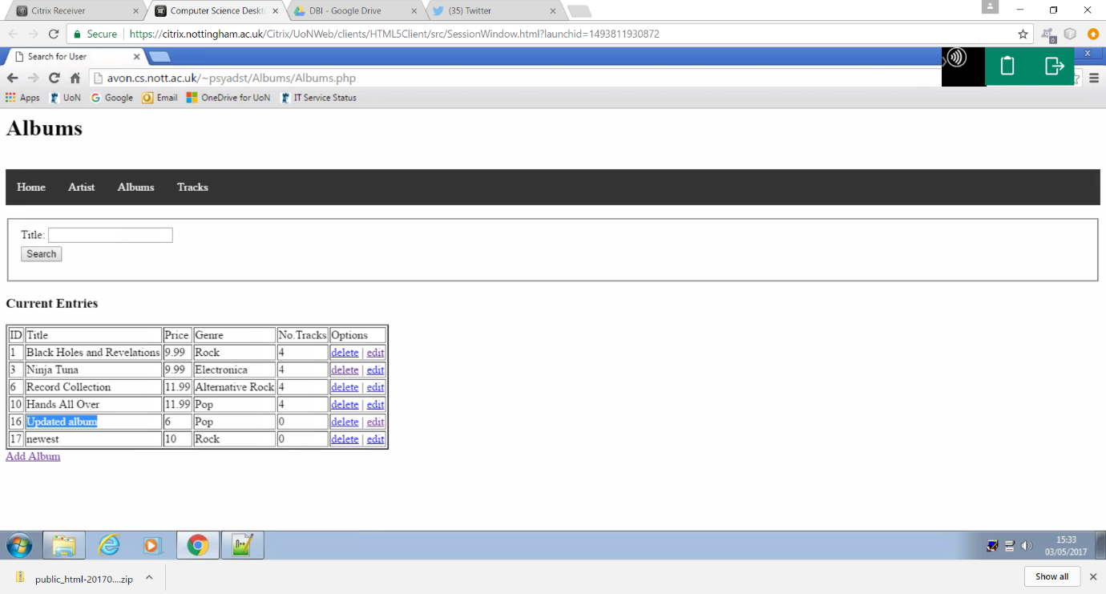

This example shows a user updating the album “new”, changing the name of the album to “update album”, the price to 6 and the genre to pop.

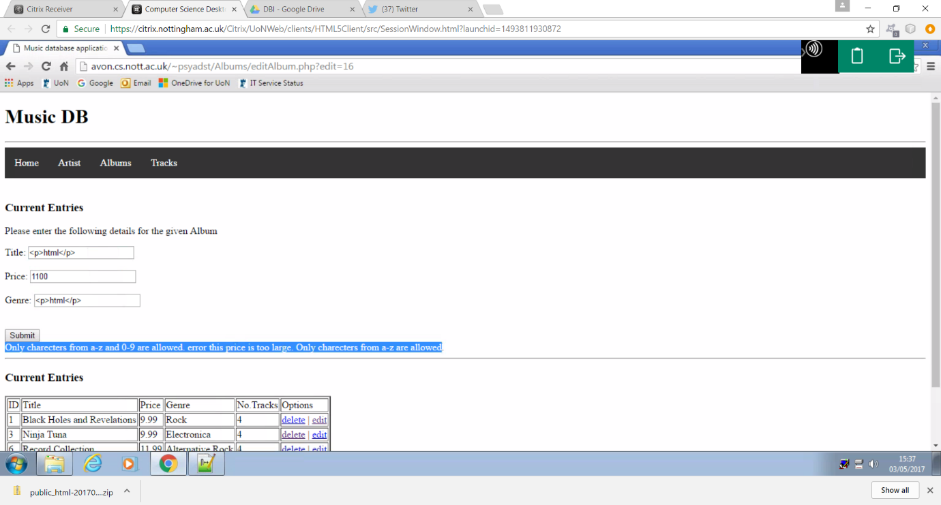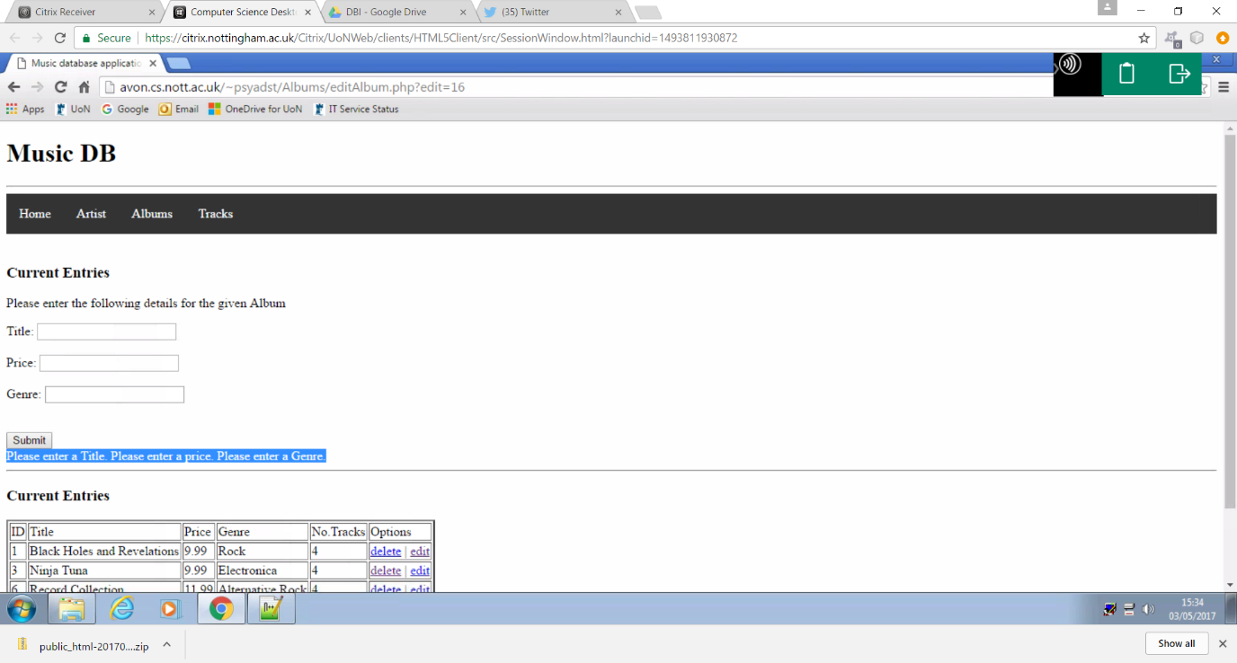From validation

The above examples demonstrate the use of a presence check, a range check and a format check on each field within the form.

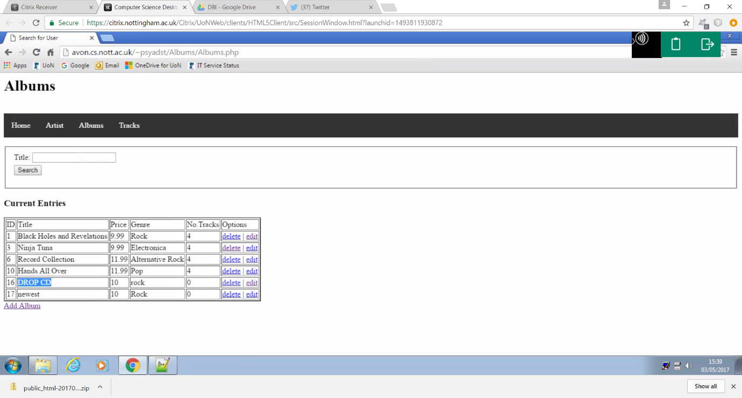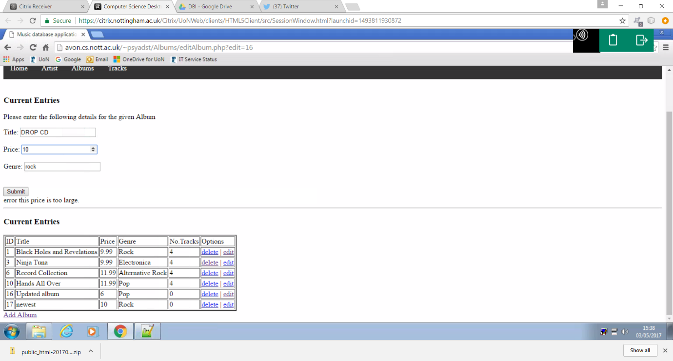

This example once again demonstrates data sanitation as discussed in form validation for artist data, preventing an sql injection.

Delete

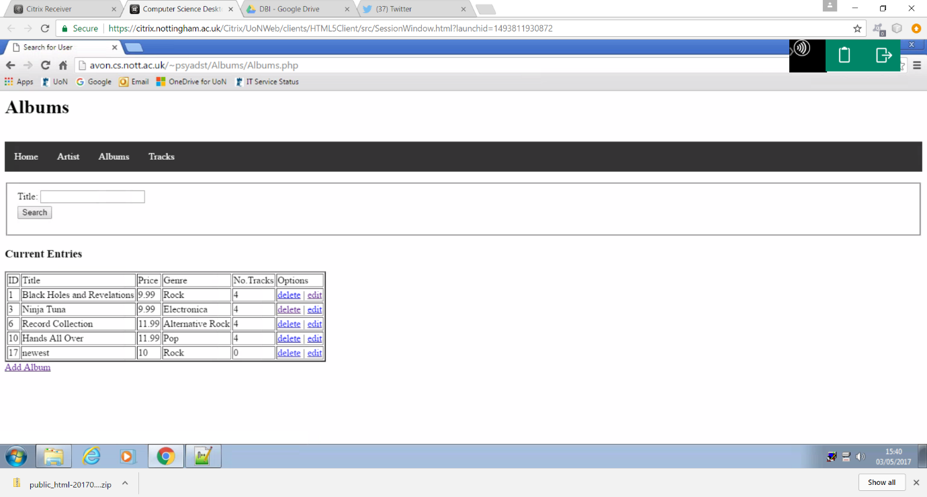

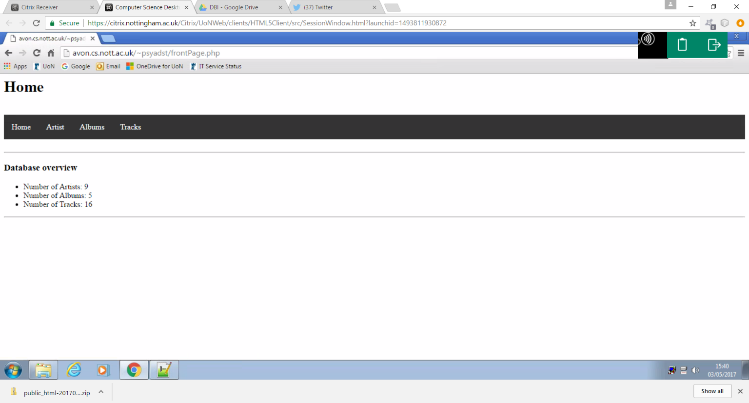

The figures above show that the deletion of“updated album”, removing the album from the database”. As a result of this the number of albums in the data base has decreased by 1.

Adding an album

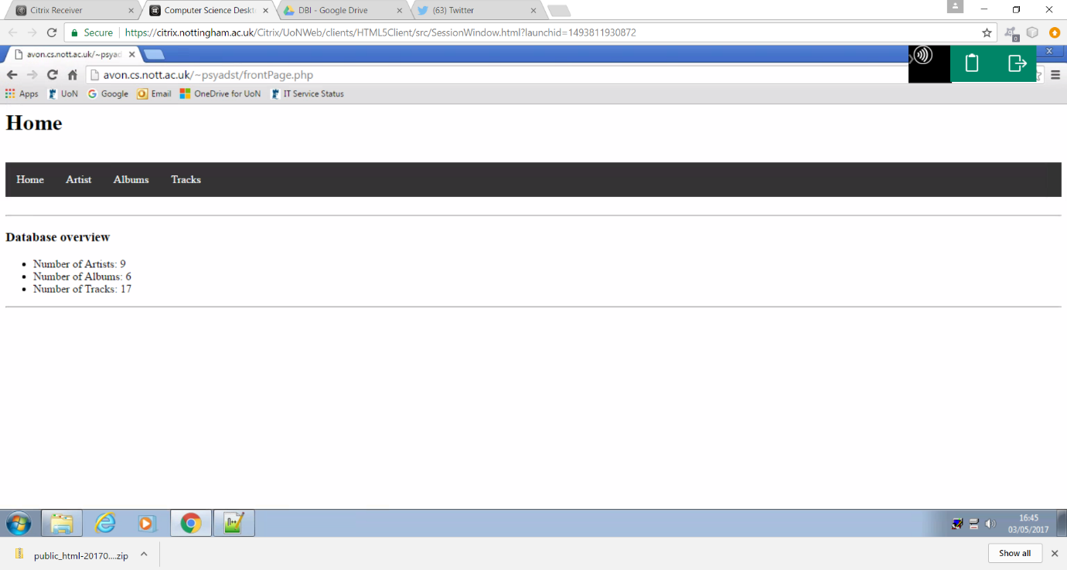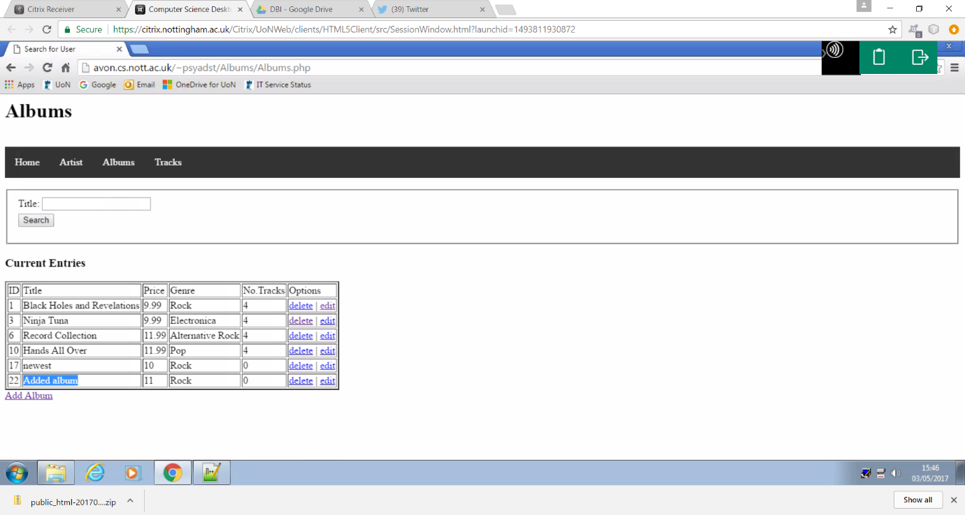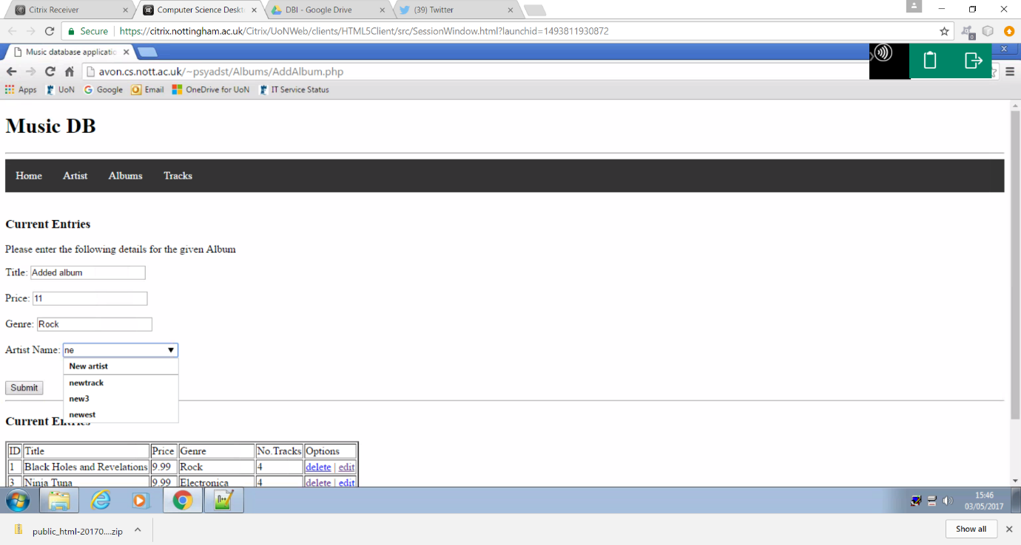

An album can be added in a similar fashion to the artist table, using a form to retrieve the title, price, genre and artist of the desired album. Once again as seen in figure two the number of albums was successfully updated. When selecting the artist, the album belongs to a live search feature is implemented showing the existing artists within the data base.

Tracks

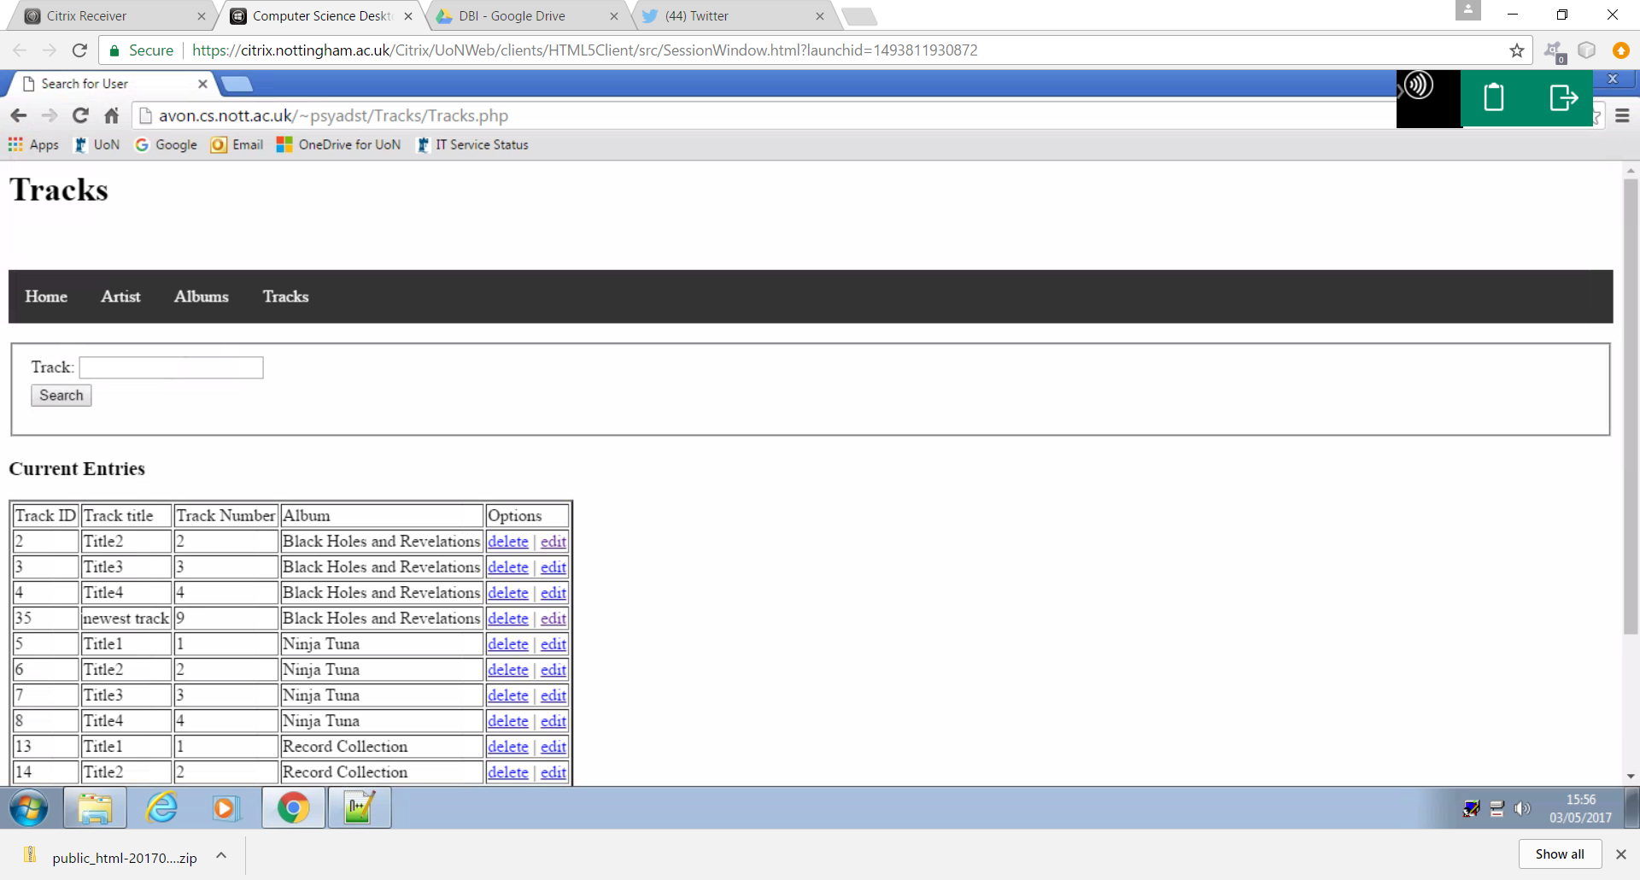

The figure above shows that the navigation bar successfully allowed the user to access the tracks section of the web site when selected. This section allows users to view, search, edit, delete and add data within the tracks table of the database.

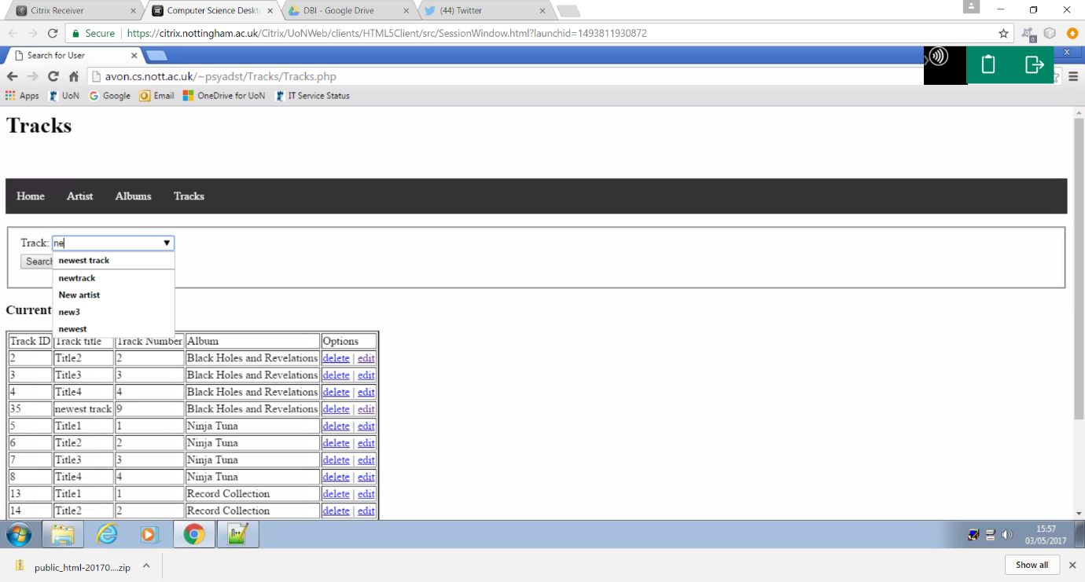Live search

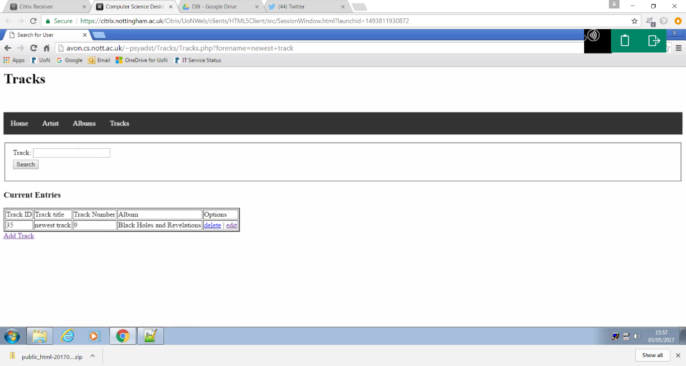

This example once again demonstrates the live search functionality, this time allowing the user to search for a given track.

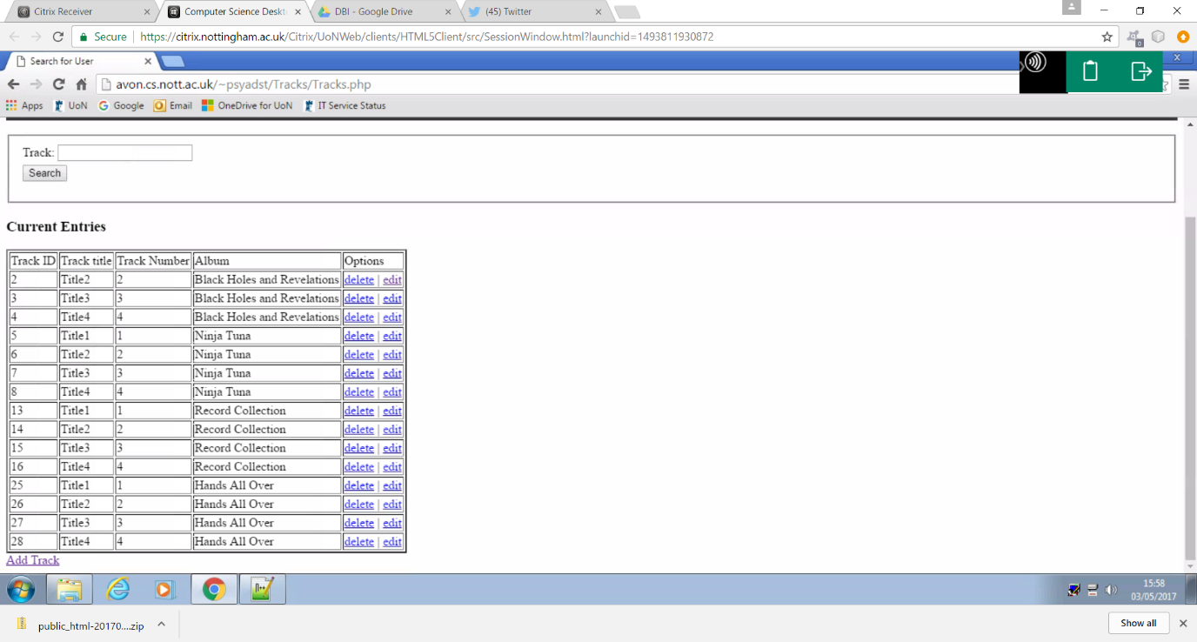Delete

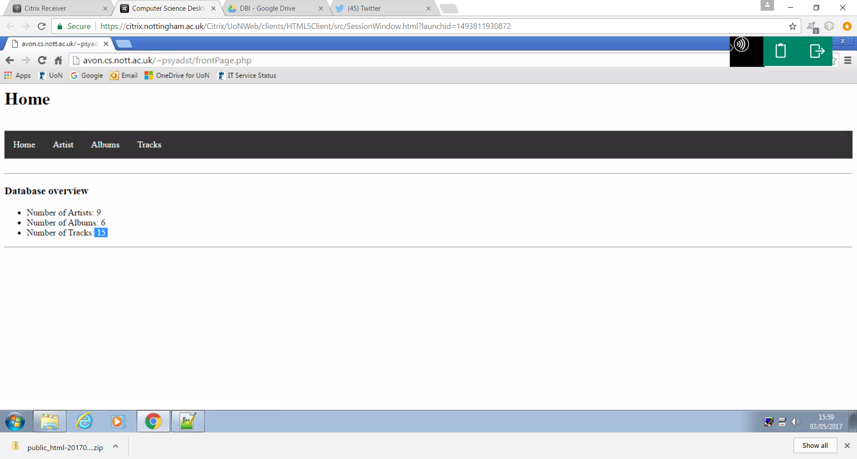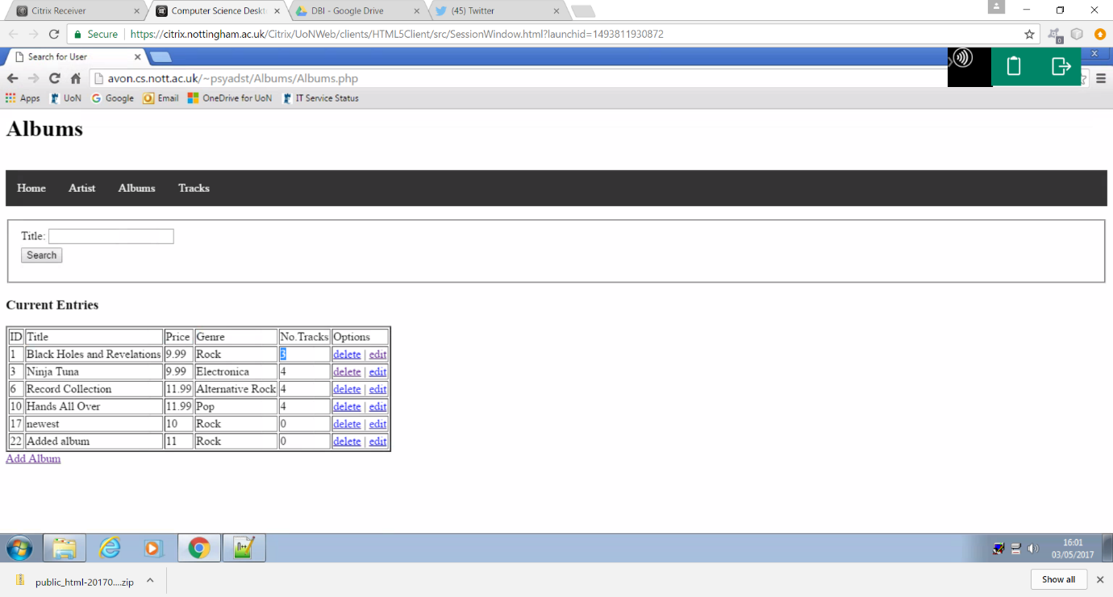

This example shows the track “newest track” being removed from the data base. As a result the track no longer appears in the table and the number of tracks has decreased both within the database and the number of tracks belonging to the album “Black Holes and Revelations” .

Edit

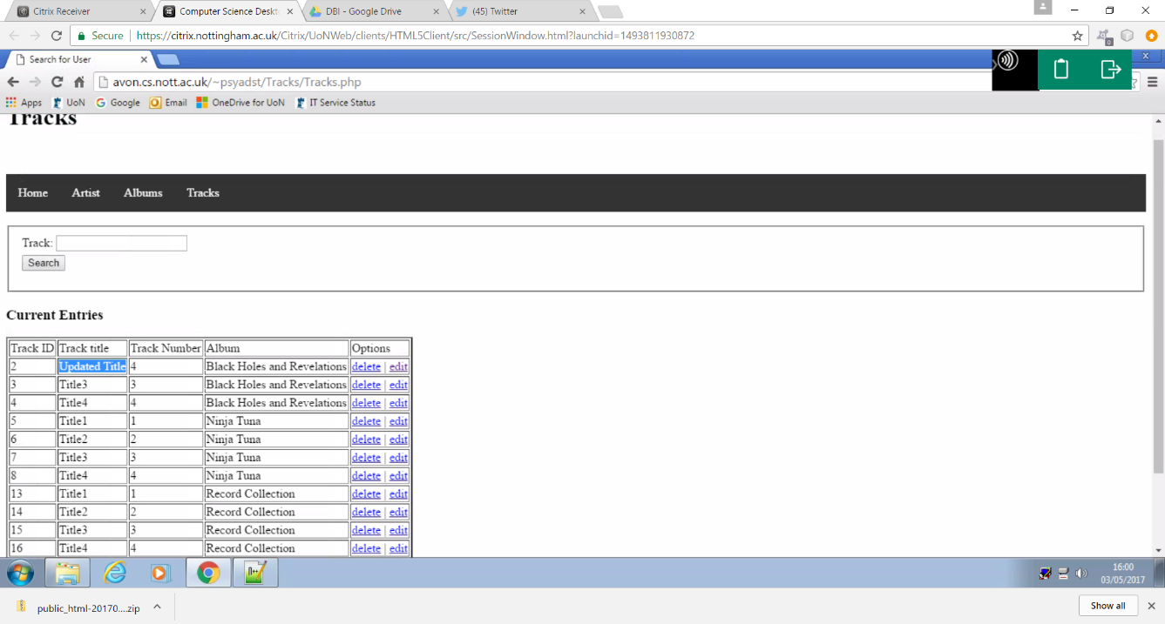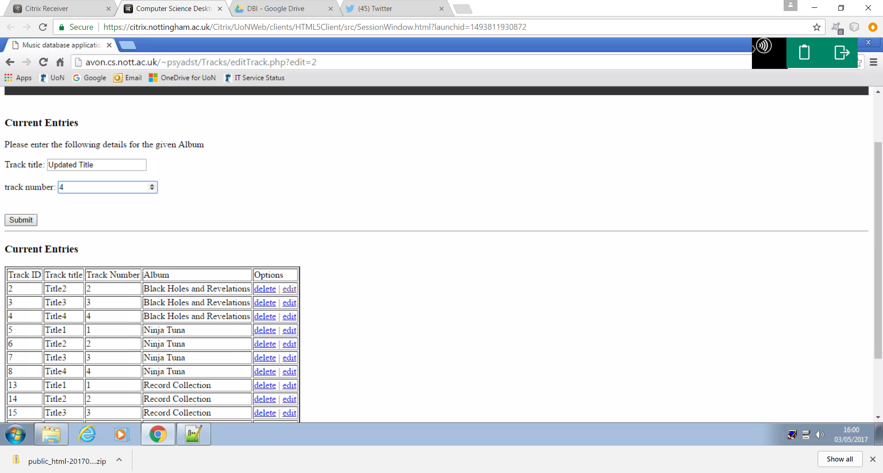

. In this example, the track “Title 2 “is being updated with the name being changed to “updated track” and the track number being changed to 4.

Add track

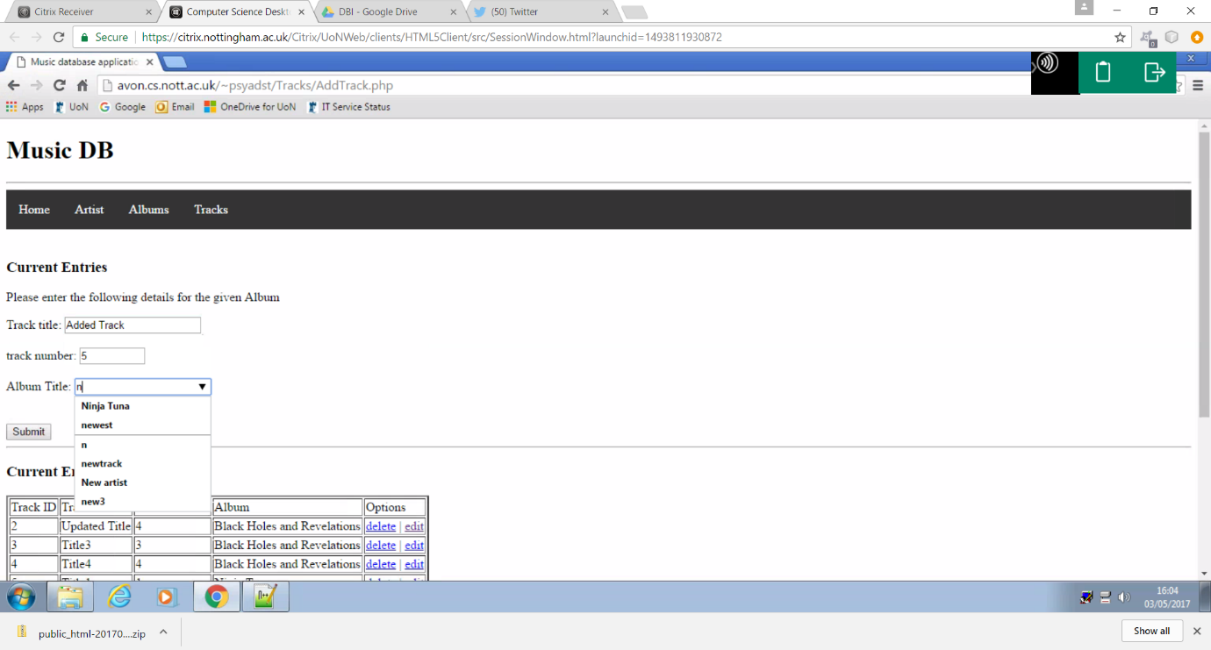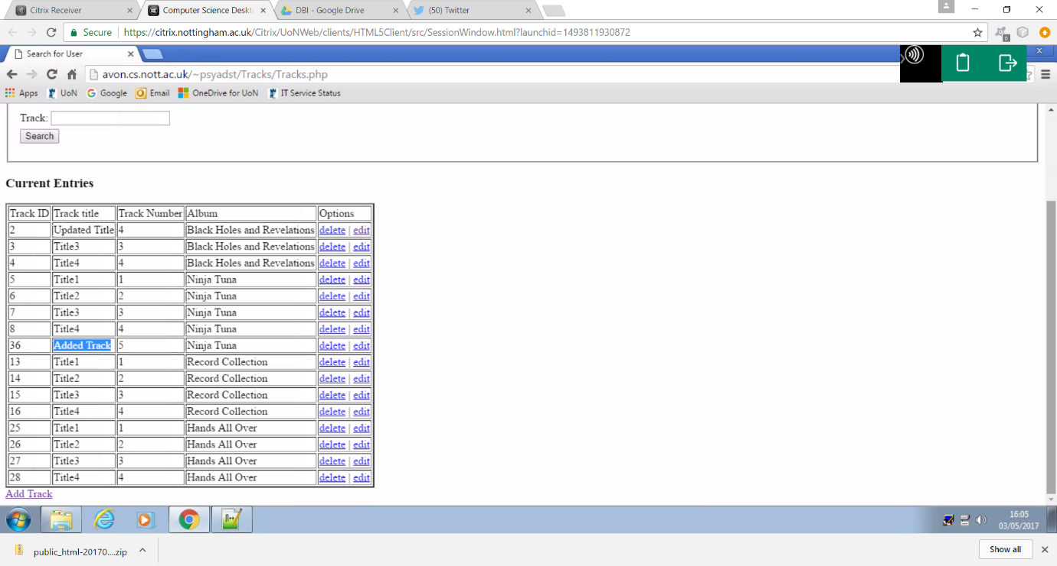

This example shows a user adding a track to the database where they select a title, track number and the album the track belongs to. When selecting the album, the track belongs to a live search feature is implemented showing the existing albums within the data base.

Form validation

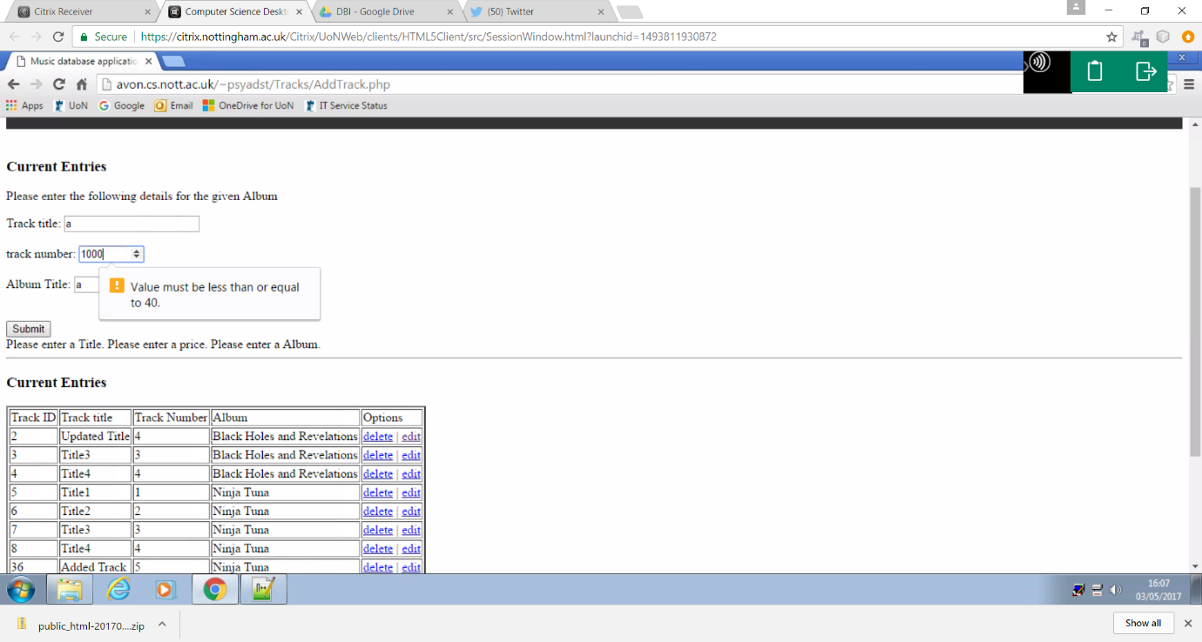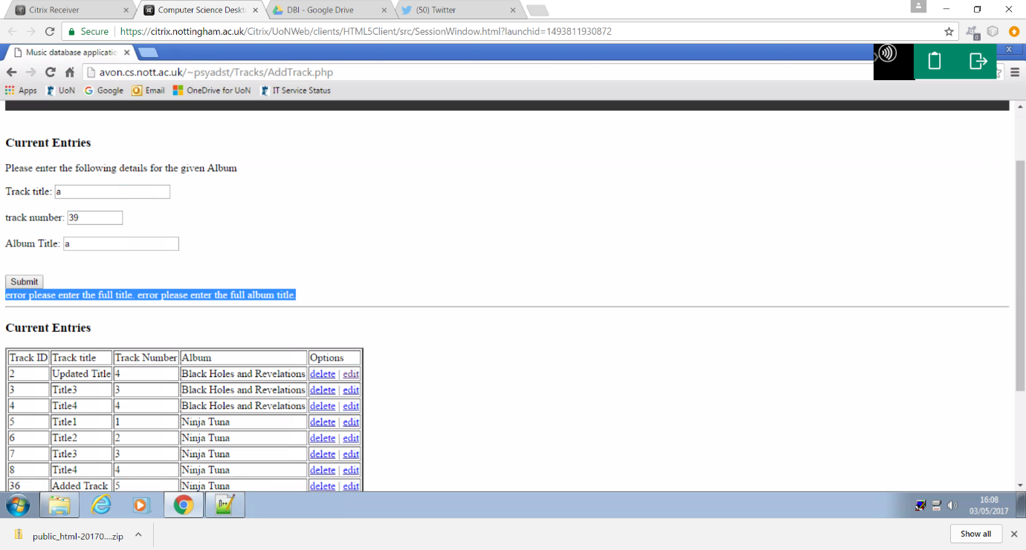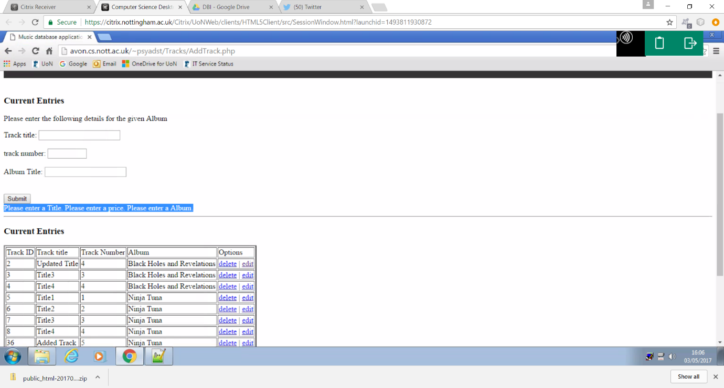

The above examples demonstrates the use of a presence check, a range check and a length check on each applicable field within the form.

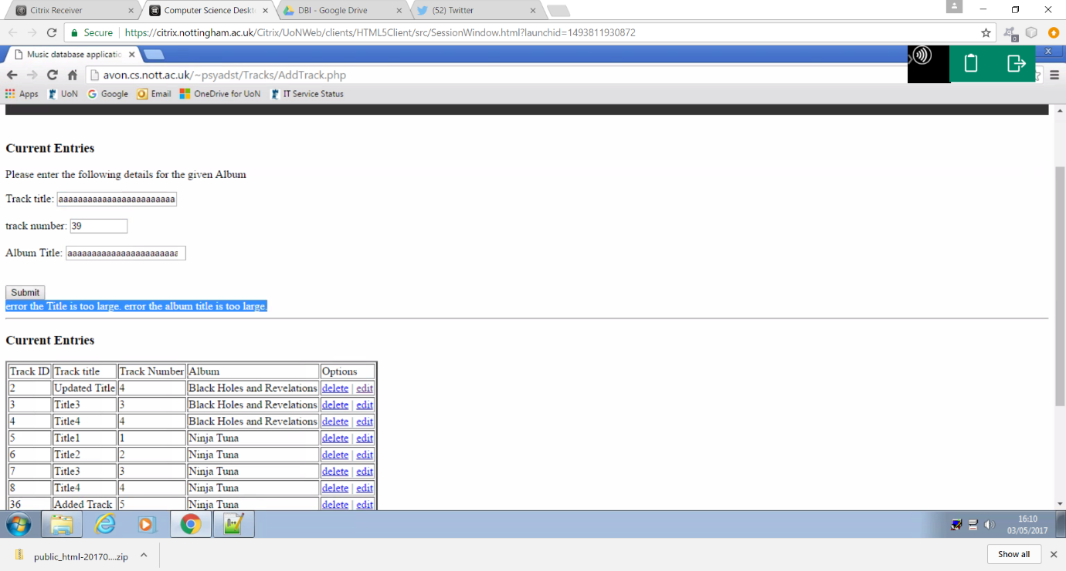The use of a length check can be seen once again in the following figure where this time the user has entered too long of a title.

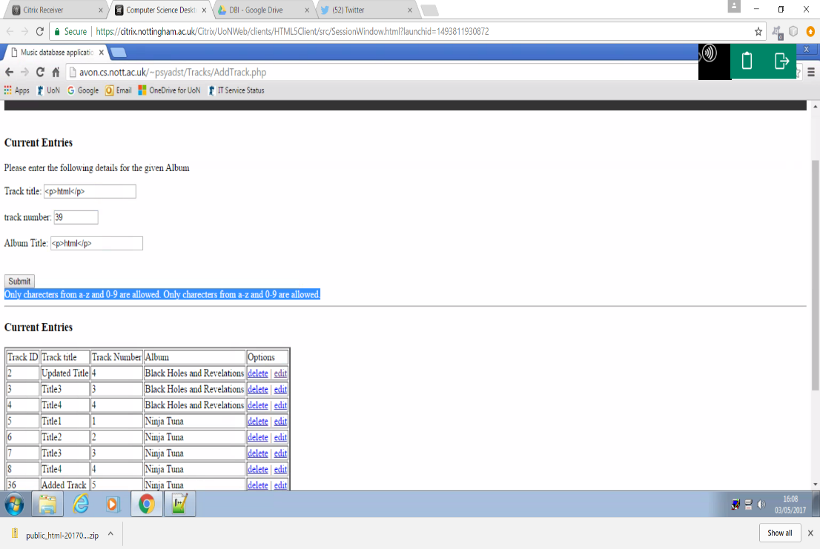This example shows the execution of a format check preventing the user from entering any characters that do not match the required format.

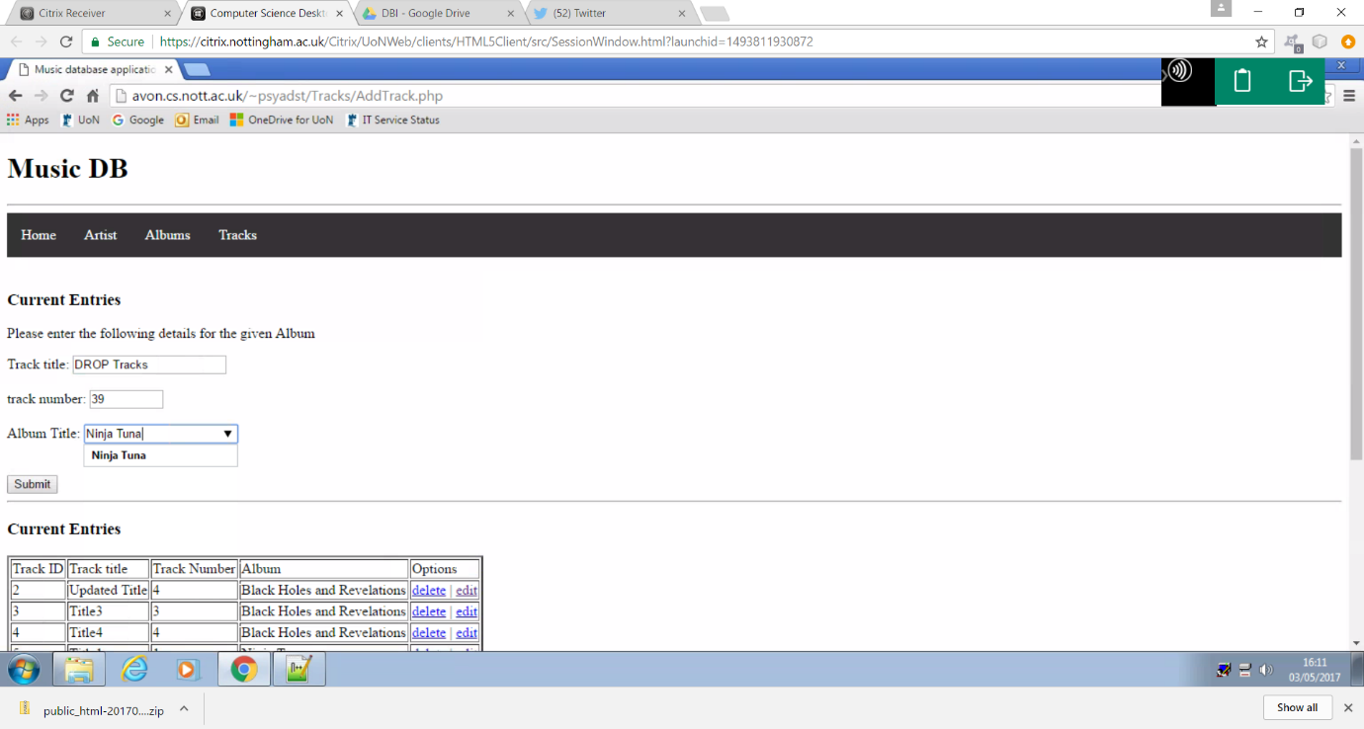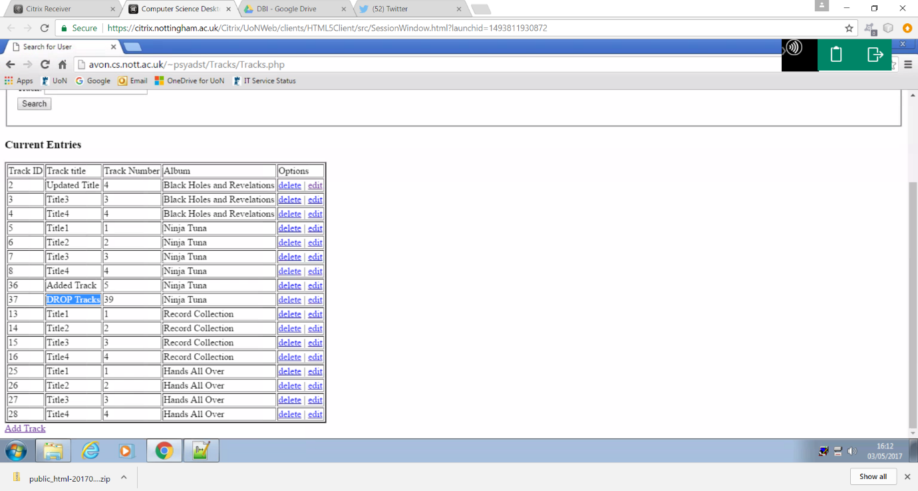

This example shows the successful execution of data sanitization preventing the user form entering any harmful code to the database, instead converting the input to the desired format.

Appendix

1.0 Frontpage

<html>

<body>

<h1>Home</h1>

<br>

<?php

include "navbar.php";

echo "<hr>";

echo"<h3>Database overview</h3>";

include 'db.php'; // database connection

$sqll = "SELECT COUNT(*) FROM Artist";

$sql2 = "SELECT COUNT(*) FROM CD";

$sql3= "SELECT COUNT(*) FROM Tracks";

//$sql3 = "SELECT * FROM Tracks";

$stmt = $conn->prepare($sqll);

$stmt->execute();

$stmt->bind_result($numl);

echo '<ul>';

while ($stmt->fetch()) {

echo '<li> Number of Artists: ' .htmlentities($numl). '</li>';

}

echo '<br>';

$stmt = $conn->prepare($sql2);

$stmt->execute();

$stmt->bind_result($num2);

while ($stmt->fetch()) {

echo '<li> Number of Albums: ' .htmlentities($num2). "</li>";

}

echo '<br>';

$stmt = $conn->prepare($sql3);

$stmt->execute();

$stmt->bind_result($num3);

while ($stmt->fetch()) {

echo '<li> Number of Tracks: ' .htmlentities($num3). '</li>';

echo "<br>";

}

echo '</ul>';

?>

<hr>

1.1 style sheet

ul {

background-color:white;

}

.homebar {list-style-type: none;

margin: 0;

padding: 0;

overflow: hidden;

background-color: #333333;

}

li {

float: left;

}

li a {

display: block;

color: white;

text-align: center;

padding: 16px;

text-decoration: none;

}

li a:hover {

background-color: #111111;

}

}

1.2 Database connection

<?php

error_reporting(-1);

ini_set('display_errors', 'On');

// Settings used to connect to the database:

$db_host = 'mysql.cs.nott.ac.uk';

$db_user = 'psyadst';

$db_pass = 'Sturgie55';

$db_name ='psyadst';

$conn = new mysqli($db_host, $db_user, $db_pass, $db_name);

if ($conn->connect_errno) echo "failed to connect to database";

?>

1.3 header

<!DOCTYPE html>

<html>

<head>

<title>Music database application</title>

</head>

<body>

<h1>Music DB</h1>

<hr />

1.4 footer

</body>

</html>

1.5 Nav bar

<head>

<link rel="stylesheet" href="../style.css">

</head>

<body>

<ul class='homebar'>

<li><a href="../frontPage.php">Home</a></li>

<li><a href="../Artist/artist.php">Artist</a></li>

<li><a href="../Albums/Albums.php">Albums</a></li>

<li><a href="../Tracks/Tracks.php">Tracks</a></li>

</ul>

<br>

1.6 Nav bar main

<head>

<link rel="stylesheet" href="style.css">

</head>

<body>

<ul class='homebar'>

<li><a href="frontPage.php">Home</a></li>

<li><a href="Artist/artist.php">Artist</a></li>

<li><a href="Albums/Albums.php">Albums</a></li>

<li><a href="Tracks/Tracks.php">Tracks</a></li>

</ul>

<br>

1.7 style sheet

ul {

background-color:white;

}

.homebar {list-style-type: none;

margin: 0;

padding: 0;

overflow: hidden;

background-color: #333333;

}

li {

float: left;

}

li a {

display: block;

color: white;

text-align: center;

padding: 16px;

text-decoration: none;

}

li a:hover {

background-color: #111111;

}

}

1.8 Java script validation

//albums

function validateTitle(entry)

{

if (entry=="")return "Please enter a Title**.\n";

else if (entry.length>50)

return "error the Title is too large.\n";

else if (entry.length<3)

return "error please enter the full title.\n";

else if (/[^a-zA-Z0-9 ]/.test(entry))

return "Only charecters from a-z and 0-9 are allowed.\n";

return "";

}

function validatePrice(entry)

{

if (entry=="")return "Please enter a price.\n";

else if (entry>13)

return "error this price is too large.\n";

else if (entry<1)

return "error this price is to small.\n";

else if (/[^0-9]/.test(entry))

return "Only numeric values are allowed.\n";

return "";

}

function validateGenre(entry)

{

if (entry=="")return "Please enter a Genre.\n";

else if (entry.length>20)

return "error genre name is too large.\n";

else if (entry.length<3)

return "error please enter full genre name.\n";

else if (/[^a-zA-Z ]/.test(entry))

return "Only charecters from a-z are allowed.\n";

return "";

}

function validateArtist(entry)

{

if (entry=="")return "Please enter a name.\n";

else if (entry.length>20)

return "error name is too large.\n";

else if (entry.length<3)

return "error please enter full name.\n";

else if (/[^a-zA-Z0-9 ]/.test(entry))

return "Only charecters from a-z and 0-9 are allowed.\n";

return "";

}

//artist

function validateName(entry)

{

if (entry=="")return "Please enter a name.\n";

else if (entry.length>20)

return "error name is too large.\n";

else if (entry.length<3)

return "error please enter full name.\n";

else if (/[^a-zA-Z0-9 ]/.test(entry))

return "Only charecters from a-z and 0-9 are allowed.\n";

return "";

}

//Tracks

function validateTracksTitle(entry)

{

if (entry=="")return "Please enter a Title**.\n";

else if (entry.length>50)

return "error the Title is too large.\n";

else if (entry.length<3)

return "error please enter the full title.\n";

else if (/[^a-zA-Z0-9 ]/.test(entry))

return "Only charecters from a-z and 0-9 are allowed.\n";

return "";

}

function validateNumber(entry)

{

if (entry=="")return "Please enter the number of tracks.\n";

else if (entry>40)

return "error the number of tracks is too large.\n";

else if (entry<1)

return "error the number of tracks is to small.\n";

else if (/[^0-9]/.test(entry))

return "Only numeric values are allowed.\n";

return "";

}

function validateAlbum(entry)

{

if (entry=="")return "Please enter a Album.\n";

else if (entry.length>70)

return "error the album title is too large.\n";

else if (entry.length<3)

return "error please enter the full album title.\n";

else if (/[^a-zA-Z0-9 ]/.test(entry))

return "Only charecters from a-z and 0-9 are allowed.\n";

return "";

}

function loadDocGet(url, cFunction, my_params) {

var request = new XMLHttpRequest();

var s = document.getElementById('fname').value;

console.log(url + '?s=' + s)

request.open("GET", url + '?s=' + s, true);

request.send();

request.onreadystatechange = function() {

if (this.readyState == 4 && this.status == 200)

cFunction(this, my_params);}

//document.getElementById("test").innerHTML = url2;

}

function myFunction(request, my_params) {

var received_j = request.responseText;

var received = JSON.parse(received_j);

//document.getElementById("test").innerHTML = nameval2;

temp = document.getElementById("Arts");

//temp.innerHTML = "";

//for (var i = 0; i < received.length; i++)

// temp.innerHTML += "<p>" + received[i] + "<p>";

for (var i = 0; i < temp.options.length; i++)

temp.options.item(i).value = " ";

for (var i = 0; i < temp.options.length; i++)

temp.options.item(i).value = received[i];

//var x = received[2];

//document.getElementById("test").innerHTML = x;

}

//function display(request, my_params) {

//alert(document.getElementById(my_params));

//var received_j = request.responseText;

//var received = JSON.parse(received_j);

//temp = document.getElementById(my_params);

// }

function loadDocPost(url, cFunction, my_params) {

var request = new XMLHttpRequest();

val1 = document.getElementById("fname").value;

params = "Art="+val1;

//document.getElementById("test").innerHTML = params;

request.open("POST", url, true);

request.setRequestHeader("Content-type", "application/x-www-form-urlencoded");

request.send(params);

request.onreadystatechange = function() {

if (this.readyState == 4 && this.status == 200)

cFunction(this, my_params);

//document.getElementById("test").innerHTML = "GG";

}

}

function myFunction2(request, my_params) {

//document.getElementById("test").innerHTML = "G1";

var received_j = request.responseText;

var received = JSON.parse(received_j);

document.getElementById("test").innerHTML = "Artist ID " + received[0] + " Artist name " + received[1] + "<br>"+ "options "+ "<a href=\"ArtistData.php?delete=$artId\">delete</a> | <a href=\"edit.php?edit=$artId\">edit</a>";

}

1.9 PHP validation

<?php

// The PHP functions

include "db.php";

function validate_Title($field)

{

if ($field == "") return "Please enter a album title.\n";

else if (strlen($field) < 3) return "The album title was too short ";

else if (strlen($field) > 50) return "The album title was too long ";

else if (preg_match("/[^a-zA-Z0-9_ ]/", $field))

return "Only letters, numbers, - and _ in the album title<br>";

return "";

}

function validate_TrackTitle($field)

{

if ($field == "") return "Please enter a track title.\n";

else if (strlen($field) < 3) return "The Track title was too short ";

else if (strlen($field) > 50) return "The Track title was too long ";

else if (preg_match("/[^a-zA-Z0-9_ ]/", $field))

return "Only letters, numbers, - and _ in the Track title<br>";

return "";

}

function validate_Genre($field)

{

if ($field == "") return "No Genre was entered<br>";

else if (strlen($field) < 3) return "The genre listed is to short";

else if (strlen($field) > 20) return "The genre listed is too long ";

else if (preg_match("/[^a-zA-Z]/", $field))

return "Only letters are allowed in the albums genre<br>";

return "";

}

function validate_Price($field)

{

if ($field == 0) return "No price was entered<br>";

else if ($field < 1 || $field > 13)

return "The price must be between £1 and £13";

else if (preg_match("/[^0-9]/", $field))

return "Only numbers are allowed in the albums price<br>";

return "";

}

function validate_Number($field)

{

if ($field == 0) return "No number was entered<br>";

else if ($field < 1 || $field > 40)

return "There can only be between must be between 1 and 40 tracks";

else if (preg_match("/[^0-9]/", $field))

return "Only numbers are allowed in the number of tracks<br>";

return "";

}

function validate_Artist($field)

{

if ($field == "") return "Please enter a name.\n";

else if (strlen($field) < 3) return "The artist name was too short ";

else if (strlen($field) > 100) return "The artist name was too long ";

else if (preg_match("/[^a-zA-Z0-9_ ]/", $field))

return "Only letters, numbers, - and _ in the artist name<br>";

return "";

}

function sterlise($string){

return htmlentities ($string);

}

?>

2.0 Artist

<html>

<head>

<link rel="stylesheet" href="../style.css">

</head>

<?php

include "../db.php";

?>

<h1>Artist</h1>

<br>

<?php

include "../navbar.php";

include "search.php";

include "displayTable.php";

?>

</body></html>

2.1 Artist Table

<h3>Current Artist's</h3>

<table border="2">

<tr>

<td>Artist ID</td>

<td>Artits name</td>

<td>Options</td>

</tr>

<?php

include "../db.php";

if (isset($_GET['Art']))

{

$stmt = $conn->prepare("SELECT artID, artName FROM Artist WHERE artName=?");

$stmt->bind_param('s', $_GET['Art']);

$stmt->execute();

//$stmt->bind_result($artId, $name);

$stmt->bind_result($artId, $name);

}

else

{

$stmt = $conn->prepare("SELECT artID, artName FROM Artist");

$stmt->execute();

$stmt->bind_result($artId, $name);

}

while ($stmt->fetch()) {

echo "<tr>";

echo " <td>$artId</td>";

echo " <td>$name</td>";

echo " <td><a href=\"ArtistData.php?delete=$artId\">delete</a> | <a href=\"edit.php?edit=$artId\">edit</a> </td>";

echo "</tr>\n";

}

?>

</table>

<a href="AddArtist.php">Add Artist</a>

2.2 delete artist

<?php

include "../header.php";

include "../db.php";

// delete an artist

if (isset($_GET['delete']))

{

echo "<p>deleting</p>";

$stmt = $conn->prepare("DELETE FROM Artist WHERE artID=?");

$stmt->bind_param('i', $_GET['delete']);

$stmt->execute();

header('Location: artist.php');

}

include "displayTable.php";

include "AddForm.php";

include "../footer.php";

2.3 add form

<?php

include "../navbar.php";

?>

<form method="post" onsubmit="return validate(this)">

<h3>Current Entries</h3>

<p>Please enter the following details for the given Artist </p>

<div>

<label>Artist Name:</label>

<input type="text" max length="20" min length="3" name="name" />

<br>

</div>

<div>

<br>

<input type="submit" />

</div>

<div id="response">

</div>

<script>

function validate(form)

{

fail=validateName(form.name.value);

if (fail=="")

{

document.write("passed");

return true;

}

else

{

//window.alert(fail);

document.getElementById("response").innerHTML =fail;

return false;

}

}

function validateName(entry)

{

if (entry=="")return "Please enter a name.\n";

else if (entry.length>20)

return "error name is too large.\n";

else if (entry.length<3)

return "error please enter full name.\n";

else if (/[^a-zA-Z0-9 ]/.test(entry))

return "Only charecters from a-z and 0-9 are allowed.\n";

return "";

}

</script>

</form>

2.4 Add artist

<?php

include "../header.php";

include "../db.php";

include "AddForm.php";

if (isset($_POST['name'])) {

$name = $_POST['name'];

if (strlen($name) < 3) {

echo "<p>Error the name is too short.</p>";

}

else {

$str1=htmlentities($name);

$q = "INSERT INTO Artist (artName) VALUES (?)";

$stmt = $conn->prepare($q);

$stmt->bind_param('s', $str1);

$stmt->execute();

header('Location: artist.php');

}

}

echo "<hr>";

include "displayTable.php";

include "../footer.php";

2.5 edit Artist

<?php

include "../header.php";

include "../db.php";

include "AddForm.php";

//edit

if (isset($_POST['name'])) {

$forename = $_POST['name'];

if (strlen($forename) < 3) {

echo "Your name is too short.";

}

else {

$str1=htmlentities($forename);

$sq = "UPDATE Artist set artName=? WHERE artID=?";

echo "<p>here</p>";

$stmt = $conn->prepare($sq);

$stmt->bind_param('si', $str1,$_GET['edit']);

$stmt->execute();

//header('Location: artist.php');

}

}

echo "<hr/>";

include "displayTable.php";

include "../footer.php";

2.6 Artist search

<!DOCTYPE html>

<html>

<head>

<title>Search for User</title>

<link rel ="stylesheet" href="my_style.css">

<script src="../validation.js"></script>

</head>

<body>

<fieldset>

<!-- <form id = "theForm" method="GET" action="get.php" > -->

<form id = "theForm" action="" >

<div style = "margin:5px">

Artist name: <input id ="fname" list="Arts" type="text" name="Art"

onkeyup="loadDocGet('find.php', myFunction, 'Arts')">

<!--<div id="Arts">

//</div>-->

<datalist id="Arts">

<option value=" ">

<option value=" ">

<option value=" ">

<option value=" ">

<option value=" ">

</datalist>

</div>

<div style = "margin:5px">

<input type="submit" value="Search">

<!-- <input type="button" value="Button" onclick="loadDocPost('get.php', myFunction2, '')">-->

</div>

</form>

</fieldset>

<div id = "test">

</div>

<script>

function loadDocGet(url, cFunction, my_params) {

var request = new XMLHttpRequest();

var s = document.getElementById('fname').value;

console.log(url + '?s=' + s)

request.open("GET", url + '?s=' + s, true);

request.send();

request.onreadystatechange = function() {

if (this.readyState == 4 && this.status == 200)

cFunction(this, my_params);}

//document.getElementById("test").innerHTML = url2;

}

function myFunction(request, my_params) {

var received_j = request.responseText;

var received = JSON.parse(received_j);

//document.getElementById("test").innerHTML = nameval2;

temp = document.getElementById("Arts");

//temp.innerHTML = "";

//for (var i = 0; i < received.length; i++)

// temp.innerHTML += "<p>" + received[i] + "<p>";

for (var i = 0; i < temp.options.length; i++)

temp.options.item(i).value = " ";

for (var i = 0; i < temp.options.length; i++)

temp.options.item(i).value = received[i];

//var x = received[2];

//document.getElementById("test").innerHTML = x;

}

//function display(request, my_params) {

//alert(document.getElementById(my_params));

//var received_j = request.responseText;

//var received = JSON.parse(received_j);

//temp = document.getElementById(my_params);

// }

function loadDocPost(url, cFunction, my_params) {

var request = new XMLHttpRequest();

val1 = document.getElementById("fname").value;

params = "Art="+val1;

//document.getElementById("test").innerHTML = params;

request.open("POST", url, true);

request.setRequestHeader("Content-type", "application/x-www-form-urlencoded");

request.send(params);

request.onreadystatechange = function() {

if (this.readyState == 4 && this.status == 200)

cFunction(this, my_params);

//document.getElementById("test").innerHTML = "GG";

}

}

function myFunction2(request, my_params) {

//document.getElementById("test").innerHTML = "G1";

var received_j = request.responseText;

var received = JSON.parse(received_j);

document.getElementById("test").innerHTML = "Artist ID " + received[0] + " Artist name " + received[1] + "<br>"+ "options "+ "<a href=\"ArtistData.php?delete=$artId\">delete</a> | <a href=\"edit.php?edit=$artId\">edit</a>";

}

</script>

</body>

</html>

2.7 find artist

<?php

//require_once 'login.php';

include "../db.php";

$x = $_GET['s'];

//$conn = new mysqli($db_host, $db_user, $db_pass, $db_name);

//if ($conn->connect_error) die($conn->connect_error);

$query = "SELECT artName FROM Artist WHERE artName LIKE '$x%'";

$stmt = $conn->prepare($query);

$stmt->execute();

$stmt->bind_result($name);

$obj = array();

$count = 0;

while ($stmt->fetch()){

$obj[$count] = $name;

$count+=1;}

$obj_j = json_encode($obj);

echo $obj_j;

$stmt->close();

$conn->close();

?>

2.8 get artist

<?php

//require_once 'login.php';

include "../db.php";

if (isset($_GET['forename']))

$forename = $_GET['forename'];

if (isset($_POST['forename']))

$forename = $_POST['forename'];

//$forename = "Jon";

//$surname = "Garibaldi";

$forename = "\"". $forename. "\"" ;

//$forename = " \"Jon\" ";

//$surname = " \"Garibaldi\" ";

//$conn = new mysqli($db_host, $db_user, $db_pass, $db_name);

//print_r($conn);

// if ($conn->connect_error){

// die($conn->connect_error);}

$query = "SELECT * FROM Artist where artName = $forename";

//echo $query;

$stmt = $conn->prepare($query);

$stmt->execute();

$stmt->bind_result($artID ,$forename);

$stmt->fetch();

$obj = [$artID,$forename];

$obj_j = json_encode($obj);

echo $obj_j;

$stmt->close();

$conn->close();

?>

3.0 Albums

<html>

<head>

<link rel="stylesheet" href="../style.css">

</head>

<h1>Albums</h1>

<br>

<?php

include "../navbar.php";

include "searchAlbum.html";

include "AlbumTable.php";

?>

</html>

3.1 Album table

<h3>Current Entries</h3>

<table border="2">

<tr>

<td>ID</td>

<td>Title</td>

<td>Price</td>

<td>Genre</td>

<td>No.Tracks</td>

<td>Options</td>

</tr>

<?php

include "../db.php";

if (isset($_GET['Title']))

{

$stmt = $conn->prepare("select CD.cdID,CD.cdTitle, CD.cdPrice, CD.cdGenre ,count(Tracks.cdID) from CD

left outer join Tracks

on CD.cdID = Tracks.cdID WHERE cdTitle=?

group by CD.cdID

order by CD.cdID;");

$stmt->bind_param('s', $_GET['Title']);

$stmt->execute();

//$stmt->bind_result($artId, $name);

$stmt->bind_result($cdID, $cdTitle, $cdPrice, $cdGenre, $cdNumTracks);

}

else

{

$stmt = $conn->prepare("select CD.cdID,CD.cdTitle, CD.cdPrice, CD.cdGenre ,count(Tracks.cdID) from CD left outer join Tracks

on CD.cdID = Tracks.cdID

group by CD.cdID

order by CD.cdID;");

$stmt->execute();

$stmt->bind_result($cdID, $cdTitle, $cdPrice, $cdGenre, $cdNumTracks);

}

while ($stmt->fetch()) {

echo "<tr>";

echo " <td>$cdID</td>";

echo " <td>$cdTitle</td>";

echo " <td>$cdPrice</td>";

echo " <td>$cdGenre</td>";

echo " <td>$cdNumTracks</td>";

echo " <td><a href=\"AlbumData.php?delete=$cdID\">delete</a> | <a href=\"editAlbum.php?edit=$cdID\">edit</a> </td>";

echo "</tr>\n";

}

?>

</table>

<a href="AddAlbum.php">Add Album</a>

3.2 Delete album

<?php

include "../header.php";

include "../db.php";

// delete an album

if (isset($_GET['delete']))

{

echo "<p>deleting</p>";

$stmt = $conn->prepare("DELETE FROM CD WHERE cdID =?");

$stmt->bind_param('i', $_GET['delete']);

$stmt->execute();

header('Location: Albums.php');

}

include "displayTable.php";

include "AddForm.php";

include "../footer.php";

3.3 add album form

<head>

<title>Edit Album</title>

<script src="../validation.js"></script>

</head>

<?php

include "../navbar.php";

?>

<form method="post" onsubmit="return validate(this)">

<h3>Current Entries</h3>

<p>Please enter the following details for the given Album </p>

<div>

<label>Title: </label>

<input type="text" max length="50" min length="3" name="Title" />

<br>

<br>

<label>Price: </label>

<input type="number" max length="20" min="1.00" max="13.00" name="price" />

<br>

<br>

<label>Genre: </label>

<input type="text" max length="20" min length="3" name="Genre" />

<br>

<br>

<!-- <form id = "theForm" method="GET" action="get.php" > -->

Artist Name: <input id ="fname" list="Arts" type="text" name="Art"

onkeyup="loadDocGet('find.php', myFunction, 'Arts')">

<!--<div id="Arts">

//</div>-->

<datalist id="Arts">

<option value=" ">

<option value=" ">

<option value=" ">

<option value=" ">

<option value=" ">

</datalist>

<!-- <input type="button" value="Button" onclick="loadDocPost('get.php', myFunction2, '')">-->

<br>

<br>

</div>

<div>

<br>

<input type="submit" />

</div>

<div id="response">

</div>

<script>

function validate(form)

{

fail= validateTitle(form.Title.value);

fail+= validatePrice(form.price.value);

fail+= validateGenre(form.Genre.value);

fail+= validateArtist(form.Art.value);

if (fail=="")

{

document.write("passed");

return true;

}

else

{

//window.alert(fail);

document.getElementById("response").innerHTML =fail;

return false;

}

}

function loadDocGet(url, cFunction, my_params) {

var request = new XMLHttpRequest();

var s = document.getElementById('fname').value;

console.log(url + '?s=' + s)

request.open("GET", url + '?s=' + s, true);

request.send();

request.onreadystatechange = function() {

if (this.readyState == 4 && this.status == 200)

cFunction(this, my_params);}

//document.getElementById("test").innerHTML = url2;

}

function myFunction(request, my_params) {

var received_j = request.responseText;

var received = JSON.parse(received_j);

//document.getElementById("test").innerHTML = nameval2;

temp = document.getElementById("Arts");

//temp.innerHTML = "";

//for (var i = 0; i < received.length; i++)

// temp.innerHTML += "<p>" + received[i] + "<p>";

for (var i = 0; i < temp.options.length; i++)

temp.options.item(i).value = " ";

for (var i = 0; i < temp.options.length; i++)

temp.options.item(i).value = received[i];

//var x = received[2];

//document.getElementById("test").innerHTML = x;

}

//function display(request, my_params) {

//alert(document.getElementById(my_params));

//var received_j = request.responseText;

//var received = JSON.parse(received_j);

//temp = document.getElementById(my_params);

// }

function loadDocPost(url, cFunction, my_params) {

var request = new XMLHttpRequest();

val1 = document.getElementById("fname").value;

params = "Art="+val1;

//document.getElementById("test").innerHTML = params;

request.open("POST", url, true);

request.setRequestHeader("Content-type", "application/x-www-form-urlencoded");

request.send(params);

request.onreadystatechange = function() {

if (this.readyState == 4 && this.status == 200)

cFunction(this, my_params);

//document.getElementById("test").innerHTML = "GG";

}

}

function myFunction2(request, my_params) {

//document.getElementById("test").innerHTML = "G1";

var received_j = request.responseText;

var received = JSON.parse(received_j);

document.getElementById("test").innerHTML = "Artist ID " + received[0] + " Artist name " + received[1] + "<br>"+ "options "+ "<a href=\"ArtistData.php?delete=$artId\">delete</a> | <a href=\"edit.php?edit=$artId\">edit</a>";

}

</script>

</form>

3.4 add album

<?php

include "../header.php";

include "../db.php";

include "AlbumForm.php";

require_once "../Albumvalidation.php";

$output_message = "";

$err = "";

$fail = "";

$Title = $Genre= $Artist = "";

$Price=0;

if (isset($_POST['Title']) && isset($_POST['Genre']) && isset($_POST['price']) && isset($_POST['Art'])){

$Title = sterlise($_POST['Title']);

$Genre = sterlise($_POST['Genre']);

$Price = sterlise($_POST['price']);

$Artist =sterlise($_POST['Art']);

$fail = validate_Title($Title);

$fail .= validate_Genre($Genre);

$fail .= validate_Price($Price);

$fail .= validate_Artist($Artist);

if ($fail == ""){

$q = "INSERT INTO CD (artID, cdTitle, cdGenre, cdPrice) VALUES

((SELECT artID from Artist WHERE artName = ?), ?, ?, ?)";

$stmt = $conn->prepare($q);

$stmt->bind_param('sssi', $Artist, $Title, $Genre, $Price);

$stmt->execute();

//header('Location: Albums.php');

}

else {

$output_message = "";

$err = "PHP validation failed, try again";

echo "<tr><td> <p> $fail </p> </td></tr> ";}

}

echo "<hr />";

//include "AlbumForm.php";

include "AlbumTable.php";

include "../footer.php";

3.5 edit album form

<head>

<head>

<title>Edit Album</title>

<script src="../validation.js"></script>

</head>

<?php

include "../navbar.php";

?>

<form method="post" onsubmit="return validate(this)">

<h3>Current Entries</h3>

<p>Please enter the following details for the given Album </p>

<div>

<label>Title: </label>

<input type="text" max length="50" min length="3" name="Title" />

<br>

<br>

<label>Price: </label>

<input type="number" max length="20" min="1.00" max="13.00" name="price" />

<br>

<br>

<label>Genre: </label>

<input type="text" max length="20" min length="3" name="Genre" />

<br>

<br>

</div>

<div>

<br>

<input type="submit" />

</div>

<div id="response">

</div>

<script>

function validate(form)

{

fail= validateTitle(form.Title.value);

fail+= validatePrice(form.price.value);

fail+= validateGenre(form.Genre.value);

if (fail=="")

{

document.write("passed");

return true;

}

else

{

//window.alert(fail);

document.getElementById("response").innerHTML =fail;

return false;

}

}

</script>

</form>

3.6 edit album

<?php

include "../header.php";

include "../db.php";

include "AlbumFormEdit.php";

require_once "../Albumvalidation.php";

$output_message = "";

$err = "";

$fail = "";

$Title = $Genre = "";

$Price=0;

if (isset($_POST['Title']) && isset($_POST['Genre']) && isset($_POST['price'])){

$Title = sterlise($_POST['Title']);

$Genre = sterlise($_POST['Genre']);

$Price = sterlise($_POST['price']);

$fail = validate_Title($Title);

$fail .= validate_Genre($Genre);

$fail .= validate_Price($Price);

if ($fail == ""){

$sq = "UPDATE CD set cdTitle=?, cdGenre=?,cdPrice=? WHERE cdID =?";

$stmt = $conn->prepare($sq);

$stmt->bind_param('ssii', $Title, $Genre, $Price, $_GET['edit']);

$stmt->execute();

//header('Location: Albums.php');

}

else {

$output_message = "";

$err = "PHP validation failed, try again";

echo "<tr><td> <p> $fail </p> </td></tr> ";}

}

echo "<hr />";

/*

Fucntion sterlise($input)

{

return htmlentities($input);

}

*/

//include "AlbumFormEdit.php";

include "AlbumTable.php";

include "../footer.php";

3.7 Album search

<!DOCTYPE html>

<html>

<head>

<title>Search for User</title>

<link rel ="stylesheet" href="my_style.css">

<script src="../validation.js"></script>

</head>

<body>

<fieldset>

<!-- <form id = "theForm" method="GET" action="get.php" > -->

<form id = "theForm" action="" >

<div style = "margin:5px">

Title: <input id ="fname" list="Titles" type="text" name="Title"

onkeyup="loadDocGet('findAlbum.php', myFunction, 'Titles')">

<!--<div id="Titles">

//</div>-->

<datalist id="Titles">

<option value=" ">

<option value=" ">

<option value=" ">

<option value=" ">

<option value=" ">

</datalist>

</div>

<div style = "margin:5px">

<input type="submit" value="Search">

<!-- <input type="button" value="Button" onclick="loadDocPost('get.php', myFunction2, '')">-->

</div>

</form>

</fieldset>

<div id = "test">

</div>

<script>

function loadDocGet(url, cFunction, my_params) {

var request = new XMLHttpRequest();

var s = document.getElementById('fname').value;

console.log(url + '?s=' + s)

request.open("GET", url + '?s=' + s, true);

request.send();

request.onreadystatechange = function() {

if (this.readyState == 4 && this.status == 200)

cFunction(this, my_params);}

//document.getElementById("test").innerHTML = url2;

}

function myFunction(request, my_params) {

var received_j = request.responseText;

var received = JSON.parse(received_j);

//document.getElementById("test").innerHTML = nameval2;

temp = document.getElementById("Titles");

//temp.innerHTML = "";

//for (var i = 0; i < received.length; i++)

// temp.innerHTML += "<p>" + received[i] + "<p>";

for (var i = 0; i < temp.options.length; i++)

temp.options.item(i).value = " ";

for (var i = 0; i < temp.options.length; i++)

temp.options.item(i).value = received[i];

//var x = received[2];

//document.getElementById("test").innerHTML = x;

}

//function display(request, my_params) {

//alert(document.getElementById(my_params));

//var received_j = request.responseText;

//var received = JSON.parse(received_j);

//temp = document.getElementById(my_params);

// }

function loadDocPost(url, cFunction, my_params) {

var request = new XMLHttpRequest();

val1 = document.getElementById("fname").value;

params = "Title="+val1;

//document.getElementById("test").innerHTML = params;

request.open("POST", url, true);

request.setRequestHeader("Content-type", "application/x-www-form-urlencoded");

request.send(params);

request.onreadystatechange = function() {

if (this.readyState == 4 && this.status == 200)

cFunction(this, my_params);

//document.getElementById("test").innerHTML = "GG";

}

}

function myFunction2(request, my_params) {

//document.getElementById("test").innerHTML = "G1";

var received_j = request.responseText;

var received = JSON.parse(received_j);

document.getElementById("test").innerHTML = "Artist ID " + received[0] + " Artist name " + received[1] + "<br>"+ "options "+ "<a href=\"ArtistData.php?delete=$artId\">delete</a> | <a href=\"edit.php?edit=$artId\">edit</a>";

}

</script>

</body>

</html>

3.8 find album

<?php

//require_once 'login.php';

include "../db.php";

$x = $_GET['s'];

//$conn = new mysqli($db_host, $db_user, $db_pass, $db_name);

//if ($conn->connect_error) die($conn->connect_error);

$query = "SELECT cdTitle FROM CD WHERE cdTitle LIKE '$x%'";

$stmt = $conn->prepare($query);

$stmt->execute();

$stmt->bind_result($name);

$obj = array();

$count = 0;

while ($stmt->fetch()){

$obj[$count] = $name;

$count+=1;}

$obj_j = json_encode($obj);

echo $obj_j;

$stmt->close();

$conn->close();

?>

3.9 get album

<?php

//require_once 'login.php';

include "../db.php";

if (isset($_GET['forename']))

$forename = $_GET['forename'];

if (isset($_POST['forename']))

$forename = $_POST['forename'];

//$forename = "Jon";

//$surname = "Garibaldi";

$forename = "\"". $forename. "\"" ;

//$forename = " \"Jon\" ";

//$surname = " \"Garibaldi\" ";

//$conn = new mysqli($db_host, $db_user, $db_pass, $db_name);

//print_r($conn);

// if ($conn->connect_error){

// die($conn->connect_error);}

$query = "SELECT * FROM CD where cdTitle = $forename";

//echo $query;

$stmt = $conn->prepare($query);

$stmt->execute();

$stmt->bind_result($cdID ,$forename);

$stmt->fetch();

$obj = [$cdID,$forename];

$obj_j = json_encode($obj);

echo $obj_j;

$stmt->close();

$conn->close();

?>

4.0 Tracks

<html>

<h1>Tracks</h1>

<br>

<br>

<?php

include "../navbar.php";

include "searchTracks.html";

include "TrackTable.php";

?>

</html>

4.0 Tracks

<html>

<h1>Tracks</h1>

<br>

<br>

<?php

include "../navbar.php";

include "searchTracks.html";

include "TrackTable.php";

?>

</html>

4.1 Track Table

<h3>Current Entries</h3>

<table border="2">

<tr>

<td>Track ID</td>

<td>Track title</td>

<td>Track Number</td>

<td>Album</td>

<td>Options</td>

</tr>

<?php

include "../db.php";

if (isset($_GET['Track']))

{

$stmt = $conn->prepare("SELECT Tracks.TrackID, Tracks.TrackTitle, Tracks.TrackNum, CD.cdTitle

FROM Tracks

INNER JOIN CD ON Tracks.cdID=CD.cdID WHERE Tracks.TrackTitle=?;");

$stmt->bind_param('s', $_GET['Track']);

$stmt->execute();

$stmt->bind_result($TrackID, $TrackTitle, $TrackNum, $Album);

}

else

{

$stmt = $conn->prepare("SELECT Tracks.TrackID, Tracks.TrackTitle, Tracks.TrackNum, CD.cdTitle

FROM Tracks

INNER JOIN CD ON Tracks.cdID=CD.cdID;");

$stmt->execute();

$stmt->bind_result($TrackID, $TrackTitle, $TrackNum, $Album);

}

while ($stmt->fetch()) {

echo "<tr>";

echo " <td>$TrackID</td>";

echo " <td>$TrackTitle</td>";

echo " <td>$TrackNum</td>";

echo " <td>$Album</td>";

echo " <td><a href=\"TrackData.php?delete=$TrackID\">delete</a> | <a href=\"editTrack.php?edit=$TrackID\">edit</a> </td>";

echo "</tr>\n";

}

?>

</table>

<a href="AddTrack.php">Add Track</a>

4.2 Delete Track

<?php

include "../header.php";

include "../db.php";

// delete a track

if (isset($_GET['delete']))

{

echo "<p>deleting</p>";

$stmt = $conn->prepare("DELETE FROM Tracks WHERE TrackID =?");

$stmt->bind_param('i', $_GET['delete']);

$stmt->execute();

header('Location: Tracks.php');

}

include "TrackTable.php";

include "TrackForm.php";

include "../footer.php";

4.3 Add track form

<head>

<title>Add Album</title>

<script src="../validation.js"></script>

</head>

<?php

include "../navbar.php";

?>

<form method="post" onsubmit="return validate(this)">

<h3>Current Entries</h3>

<p>Please enter the following details for the given Album </p>

<div>

<label>Track title: </label>

<input type="text" max length="50" min length="3" name="Title" />

<br>

<br>

<label>track number: </label>

<input type="number" min="1.00" max="40.00" name="Number" />

<br>

<br>

<!-- <form id = "theForm" method="GET" action="get.php" > -->

Album Title: <input id ="fname" list="Albums" type="text" name="Album"

onkeyup="loadDocGet('findAlbum.php', myFunction, 'Albums')">

<!--<div id="Albums">

//</div>-->

<datalist id="Albums">

<option value=" ">

<option value=" ">

<option value=" ">

<option value=" ">

<option value=" ">

</datalist>

<!-- <input type="button" value="Button" onclick="loadDocPost('get.php', myFunction2, '')">-->

<br>

<br>

</div>

<div>

<br>

<input type="submit" />

</div>

<div id="response">

</div>

<script>

function validate(form)

{

fail= validateTracksTitle(form.Title.value);

fail+= validateNumber(form.Number.value);

fail+= validateAlbum(form.Album.value);

if (fail=="")

{

document.write("passed");

return true;

}

else

{

//window.alert(fail);

document.getElementById("response").innerHTML =fail;

return false;

}

}

function loadDocGet(url, cFunction, my_params) {

var request = new XMLHttpRequest();

var s = document.getElementById('fname').value;

console.log(url + '?s=' + s)

request.open("GET", url + '?s=' + s, true);

request.send();

request.onreadystatechange = function() {

if (this.readyState == 4 && this.status == 200)

cFunction(this, my_params);}

//document.getElementById("test").innerHTML = url2;

}

function myFunction(request, my_params) {

var received_j = request.responseText;

var received = JSON.parse(received_j);

//document.getElementById("test").innerHTML = nameval2;

temp = document.getElementById("Albums");

//temp.innerHTML = "";

//for (var i = 0; i < received.length; i++)

// temp.innerHTML += "<p>" + received[i] + "<p>";

for (var i = 0; i < temp.options.length; i++)

temp.options.item(i).value = " ";

for (var i = 0; i < temp.options.length; i++)

temp.options.item(i).value = received[i];

//var x = received[2];

//document.getElementById("test").innerHTML = x;

}

//function display(request, my_params) {

//alert(document.getElementById(my_params));

//var received_j = request.responseText;

//var received = JSON.parse(received_j);

//temp = document.getElementById(my_params);

//

function loadDocPost(url, cFunction, my_params) {

var request = new XMLHttpRequest();

val1 = document.getElementById("fname").value;

params = "Album="+val1;

//document.getElementById("test").innerHTML = params;

request.open("POST", url, true);

request.setRequestHeader("Content-type", "application/x-www-form-urlencoded");

request.send(params);

request.onreadystatechange = function() {

if (this.readyState == 4 && this.status == 200)

cFunction(this, my_params);

//document.getElementById("test").innerHTML = "GG";

}

}

function myFunction2(request, my_params) {

//document.getElementById("test").innerHTML = "G1";

var received_j = request.responseText;

var received = JSON.parse(received_j);

document.getElementById("test").innerHTML = "Artist ID " + received[0] + " Artist name " + received[1] + "<br>"+ "options "+ "<a href=\"ArtistData.php?delete=$artId\">delete</a> | <a href=\"edit.php?edit=$artId\">edit</a>";

}

</script>

</form>

4.4 Add track

<?php

include "../header.php";

include "../db.php";

include "TrackForm.php";

require_once "../Albumvalidation.php";

$output_message = "";

$err = "";

$fail = "";

$Title = $Album = "";

$Number=0;

if (isset($_POST['Title']) && isset($_POST['Number']) && isset($_POST['Album'])){

$Title = sterlise($_POST['Title']);

$Number = sterlise($_POST['Number']);

$Album = sterlise($_POST['Album']);

$fail = validate_TrackTitle($Title);

$fail .= validate_Number($Number);

$fail .= validate_Title($Album);

if ($fail == ""){

$q = "INSERT INTO Tracks (cdID, TrackTitle, TrackNum) VALUES

((SELECT cdID from CD WHERE cdTitle = ?), ?, ?)";

$stmt = $conn->prepare($q);

$stmt->bind_param('ssi', $Album, $Title, $Number);

$stmt->execute();

//header('Location: Tracks.php');

}

else {

$output_message = "";

$err = "PHP validation failed, try again";

echo "<tr><td> <p> $fail </p> </td></tr> ";}

}

echo "<hr />";

//include "TrackForm.php";

include "TrackTable.php";

include "../footer.php";

4.5 edit Track form

<head>

<title>Edit Album</title>

<script src="../validation.js"></script>

</head>

<?php

include "../navbar.php";

?>

<form method="post" onsubmit="return validate(this)">

<h3>Current Entries</h3>

<p>Please enter the following details for the given Album </p>

<div>

<label>Track title: </label>

<input type="text" max length="50" min length="3" name="Title" />

<br>

<br>

<label>track number: </label>

<input type="number" max length="20" min="1.00" max="40.00" name="Number" />

<br>

<br>

</div>

<div>

<br>

<input type="submit" />

</div>

<div id="response">

</div>

<script>

function validate(form)

{

fail= validateTracksTitle(form.Title.value);

fail+= validateNumber(form.Number.value);

if (fail=="")

{

document.write("passed");

return true;

}

else

{

//window.alert(fail);

document.getElementById("response").innerHTML =fail;

return false;

}

}

</script>

</form>

4.6 edit Track

<?php

include "../header.php";

include "../db.php";

include "TrackFormEdit.php";

require_once "../Albumvalidation.php";

$output_message = "";

$err = "";

$fail = "";

$Title = "";

$Number=0;

if (isset($_POST['Title']) && isset($_POST['Number'])){

$Title = sterlise($_POST['Title']);

$Number = sterlise($_POST['Number']);

$fail = validate_TrackTitle($Title);

$fail .= validate_Number($Number);

if ($fail == ""){

$sq = "UPDATE Tracks set TrackTitle=?, TrackNum=? WHERE TrackID =?";

$stmt = $conn->prepare($sq);

$stmt->bind_param('sii', $Title, $Number, $_GET['edit']);

$stmt->execute();

//header('Location: Tracks.php');

}

else {

$output_message = "";

$err = "PHP validation failed, try again";

echo "<tr><td> <p> $fail </p> </td></tr> ";}

}

echo "<hr />";

/*

Fucntion sterlise($input)

{

return htmlentities($input);

}

*/

//include "TrackFormEdit.php";

include "TrackTable.php";

include "../footer.php";

4.7 Track search

<!DOCTYPE html>

<html>

<head>

<title>Search for User</title>

<link rel ="stylesheet" href="my_style.css">

<script src="../validation.js"></script>

</head>

<body>

<fieldset>

<!-- <form id = "theForm" method="GET" action="get.php" > -->

<form id = "theForm" action="" >

<div style = "margin:5px">

Track: <input id ="fname" list="Tracks" type="text" name="Track"

onkeyup="loadDocGet('findTrack.php', myFunction, 'Tracks')">

<!--<div id="Tracks">

//</div>-->

<datalist id="Tracks">

<option value=" ">

<option value=" ">

<option value=" ">

<option value=" ">

<option value=" ">

</datalist>

</div>

<div style = "margin:5px">

<input type="submit" value="Search">

<!-- <input type="button" value="Button" onclick="loadDocPost('get.php', myFunction2, '')">-->

</div>

</form>

</fieldset>

<div id = "test">

</div>

<script>

function loadDocGet(url, cFunction, my_params) {

var request = new XMLHttpRequest();

var s = document.getElementById('fname').value;

console.log(url + '?s=' + s)

request.open("GET", url + '?s=' + s, true);

request.send();

request.onreadystatechange = function() {

if (this.readyState == 4 && this.status == 200)

cFunction(this, my_params);}

//document.getElementById("test").innerHTML = url2;

}

function myFunction(request, my_params) {

var received_j = request.responseText;

var received = JSON.parse(received_j);

//document.getElementById("test").innerHTML = nameval2;

temp = document.getElementById("Tracks");

//temp.innerHTML = "";

//for (var i = 0; i < received.length; i++)

// temp.innerHTML += "<p>" + received[i] + "<p>";

for (var i = 0; i < temp.options.length; i++)

temp.options.item(i).value = " ";

for (var i = 0; i < temp.options.length; i++)

temp.options.item(i).value = received[i];

//var x = received[2];

//document.getElementById("test").innerHTML = x;

}

//function display(request, my_params) {

//alert(document.getElementById(my_params));

//var received_j = request.responseText;

//var received = JSON.parse(received_j);

//temp = document.getElementById(my_params);

// }

function loadDocPost(url, cFunction, my_params) {

var request = new XMLHttpRequest();

val1 = document.getElementById("fname").value;

params = "Track="+val1;

//document.getElementById("test").innerHTML = params;

request.open("POST", url, true);

request.setRequestHeader("Content-type", "application/x-www-form-urlencoded");

request.send(params);

request.onreadystatechange = function() {

if (this.readyState == 4 && this.status == 200)

cFunction(this, my_params);

//document.getElementById("test").innerHTML = "GG";

}

}

function myFunction2(request, my_params) {

//document.getElementById("test").innerHTML = "G1";

var received_j = request.responseText;

var received = JSON.parse(received_j);

document.getElementById("test").innerHTML = "Artist ID " + received[0] + " Artist name " + received[1] + "<br>"+ "options "+ "<a href=\"ArtistData.php?delete=$artId\">delete</a> | <a href=\"edit.php?edit=$artId\">edit</a>";

}

</script>

</body>

</html>

4.8 Find Track

<?php

//require_once 'login.php';

include "../db.php";

$x = $_GET['s'];

//$conn = new mysqli($db_host, $db_user, $db_pass, $db_name);

//if ($conn->connect_error) die($conn->connect_error);

$query = "SELECT TrackTitle FROM Tracks WHERE TrackTitle LIKE '$x%'";

$stmt = $conn->prepare($query);

$stmt->execute();

$stmt->bind_result($name);

$obj = array();

$count = 0;

while ($stmt->fetch()){

$obj[$count] = $name;

$count+=1;}

$obj_j = json_encode($obj);

echo $obj_j;

$stmt->close();

$conn->close();

?>

4.9 Get track

<?php

//require_once 'login.php';

include "../db.php";

if (isset($_GET['forename']))

$forename = $_GET['forename'];

if (isset($_POST['forename']))

$forename = $_POST['forename'];

//$forename = "Jon";

//$surname = "Garibaldi";

$forename = "\"". $forename. "\"" ;

//$forename = " \"Jon\" ";

//$surname = " \"Garibaldi\" ";

//$conn = new mysqli($db_host, $db_user, $db_pass, $db_name);

//print_r($conn);

// if ($conn->connect_error){

// die($conn->connect_error);}

$query = "SELECT * FROM Tracks where TrackTitle = $forename";

//echo $query;

$stmt = $conn->prepare($query);

$stmt->execute();

$stmt->bind_result($TrackID ,$forename);

$stmt->fetch();

$obj = [$TrackIDID,$forename];

$obj_j = json_encode($obj);

echo $obj_j;

$stmt->close();

$conn->close();

?>